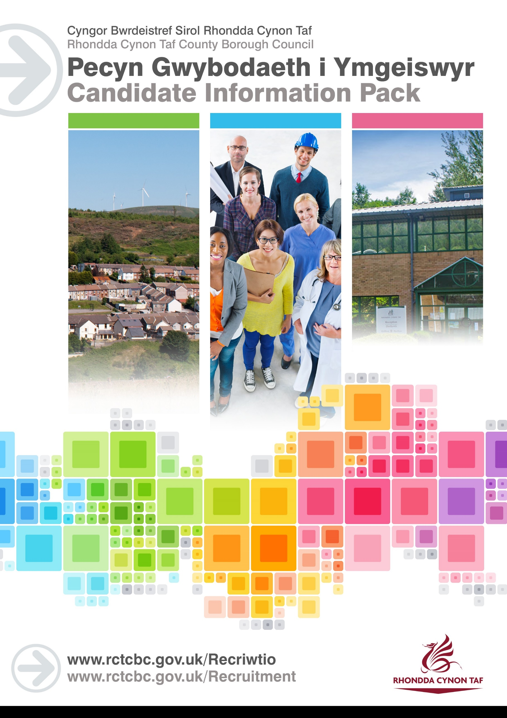

JOB DESCRIPTION

NIGHT RESIDENTIAL CHILDCARE PRACTITIONER

Post Reference Number: 195
Date of Job Description: February 2023

 | Salary and Grade | 6
 | Location | Bryndar Community Home

 | Group | COMMUNITY & CHILDREN’S SERVICES
 | Department / Division | CHILDREN’S SERVICES
 | Team / Section | FAMILY SUPPORT AND ACCOMODATION SERVICES

 | Responsible to: | REGISTERED MANAGER
 | Posts reporting to this post: | NONE
 | DBS Required | YES ENHANCED – CHILD WITH 3 YEARLY RENEWAL

Key Objectives
The Night Residential Child Care Practitioner will play a key role in the team that ensures the provision of a skilled and expert service to children/young people and their families/carers who are experiencing difficulties, by providing planned and same day placements to children/young. The role will involve meeting the individual needs of children and young people throughout the night. This will involve working directly with children, young people and their families, carers and other professionals.

The Night Residential Child Care Practitioner will work in an innovative, trauma informed way to ensure positive outcomes, with a compassionate approach. This will include having a clear understanding of trauma, and how this can have an impact on an individual’s sleeping pattern, their ability to settle and the need for support during the night.

To safeguard and promote the wellbeing of vulnerable children and young people who are in crisis, by following their personal plans of care and support.

To complete written reports as required in line with Children's Services policies and practices, and in line with the requirements of The Regulation and Inspection of Social Care (Wales) Act 2016

To liaise directly with other services and agencies during the night, and report issues swiftly.

To ensure children and young people are supported away from the home during the night, in situations where they may be missing, or require hospital treatment

To ensure that the views of children/young people are listened to as part of their care

To ensure that the home is prepared for the start of each new day

Why work for Rhondda Cynon Taf Council?

Rhondda Cynon Taf Council Children's Services is pleased to host Residential Children’s posts within its Childrens Residential Service.
All our staff have the chance to influence the development of our work and are supported by a strong, experienced management team both at strategic and operational levels.
We recognise that working in Social Care is professionally and personally challenging and demands considerable levels of skill, commitment, and enthusiasm. We offer a dedicated in-house Learning and Development Centre which actively supports our staff to maintain their skills and Continuous Professional Development.
RCT Council employees also have access to a wide range of staff benefits which include:
- Successful applicants who do not hold the relevant qualification will be supported to achieve the QCF Level 3 Diploma in Health and Social Care (Children and Young People) within 2 years of registration with Social Care Wales
- 26 days Annual Leave, rising to 31 days after 5 years’ service
- Cycle to Work Scheme
- Discounted LeisureForLife Membership
- Vectis Card (staff discount)
- Technology Purchase Scheme

Purpose of the post:

SPECIFIC RESPONSIBILITY

1.To work with others within the team to plan and deliver individual programmes of trauma informed care and support for children/young people,their families/carers.

2. The Night Residential Child Care Practitioner will be flexiable in their approach to delivering interventions and as such will work on a flexiable rota, including weekends and statutory holidays.

3.To deliver trauma informed interventions to children/ young people who experience difficulties during the night

4. To deliver interventions which support the strengths of children/young people

5. To provide structure and routine to every day life, through planned activities and interventions

6.To contribute to the structure and routine of the day by carrying out routine tasks, such as preparing meals, laundry, cleaning, and supporting children/young people to make a contribution to this

7.To participate, with other team members, in taking children/young people on activites which are designed to form positive relationships and trust.

8.To build professional relationships with children/ young people and their families and to use that relationship to safeguard and promote positive outcome

9.To work directly with children/young people

10.To promote the wellbeing of children and young people, by encouraging an interest in education, community and a healthy lifestyle.

11.To be alert to signs of distress or abuse, and to ensure that the children and young people are monitored and protected.

12.To report any practice concerns to the relevant manager without delay

13. To understand and respect the rights of children and young people

14.To maintain records using the required ICT system

15.To undertake recording in line with Divisional procedures

16. To inform colleagues of relevant developments and engage in handover between shifts

17. To share information about children/ young people with other agencies in order to safeguard them and promote their welfare in line with the requirements of the Data Protection Act

18.To identify and record risk and contribute to the management of these

19. To provide for children's/young people's physical needs where necessary, and part of the personal plan

20. To administer medication in line with the personal plan

21. To deal promptly and sensitivley to complaints from those using the service, within the framework of the Councils Complaints Procedure

22. Promote the welfare and wellbeing of children /young people and when appropriate advocate for them

23.To act as a team member, supporting collegues and accepting support as necessary

24. To work flexibly, within reasonable bounds, in order to ensure the necessary cover for the service

25.To work jointly with team colleagues on identified cases

26.To engage in practical activities within the home to ensure it's upkeep, and safety

27. To transport children/young people to hospital,from friends or police stations where safe to do so, in line Parental Duties

28.To be accountable for all monies allocated for specific purposes

29. To participate in regular supervision in line with The Regulation and Inspection of Social Care (Wales) Act 2016

30.To participate in training and staff development programmes as deemed appropriate by the Line Manager

31.To provide a service which is anti -discriminatory on the grounds of race, sex, age, marital status, sexual orientation, disability, religion or nationality

32.To operate Health and Safety standards and procedures, which comply with statutory requirements and the Divisions policies

33.To comply with legislation, regulations, polices, procedures and standards of good practice

34.To work in line with the Code of Professional Conduct

To carry out health and safety responsibilities in accordance with the Division’s Health & Safety Responsibilities document.

To undertake such other duties and responsibilities commensurate with the grade, as may be reasonably required by the Director, or as a mutually agreed development opportunity.

THE CONTENTS OF THE DOCUMENT WILL BE SUBJECT TO REVIEW FROM TIME TO TIME IN CONSULTATION WITH THE POST HOLDER. JOB DESCRIPTIONS MAY BE AMENDED TO REFLECT AND RECORD SUCH CHANGES.

Protecting Children and Vulnerable Adults is a core responsibility of all staff. All safeguarding concerns should be reported to the Cwm Taf Multi-Agency Safeguarding Hub (MASH)

PERSON SPECIFICATION
This Person Specification sets out the knowledge and/ or qualifications and/or qualifications, past experience and personal competencies that would be ideal for this particular post.

The Knowledge/ Qualifications and Experience sections describe what is required in terms of the technical ability that is needed to do this job successfully.

The Competencies section describes the kinds of non-technical skills, abilities and personal characteristics that the ideal person for this particular role would have. The competencies describe how that person would ideally work with other people and how they would approach their responsibilities.

The Special Conditions and Professional Requirements section describes any other qualities appropriate to the particular circumstances associated with this role.

Knowledge / Education:
 | Essential | Desirable
 | A firm commitment to continuous professional development  Welsh Language Level 1 - All employees will be required to undertake a basic Welsh Language Induction to reach this level. Please refer to The Welsh Language Skills Guidance online www.rctcbc.gov.uk/WelshSkills  A commitment to undertake and complete QCF Level 3 Diploma in Health and Social Care (Children and Young People) within 2 years of registration with Social Care Wales  An understanding of the Rights of Children and Young People  The ability to travel independently in the course of the duties required by the post | Welsh Language Level 2 to Level 5.  For details on the levels please refer to The Welsh Language Skills Guidelines, which can be found in the Welsh Services section of the RCT Council Website.  QCF /NVQ Level 3 Diploma in Health and Social Care (Children and Young People)  Experience of working with Children and Young People in crisis

Experience:
 | Essential | Desirable
 | Can demonstrate a having participated in the direct care of children or young people | A proven commitment to working with children/ young people who are in crisis

How we expect you to behave in work:

 | Competency Framework | Community & Social Care Competency Framework
 | Competency Areas
 | Looking after service users best interests | Listens to views of the service user and includes those involved with the service user to define the best way forward  Supports and enables service users to make decisions
 | Achieving Results | Takes responsibility  Is flexible, can switch tasks/roles/priorities to deal with new demands, changes or new information  Demonstrates professional competence and consistently delivers high quality outcomes
 | Working with Partners | Works to overcome conflicting viewpoints for the best interest of the service user  Recognises the value and expertise of others in the wider environment  Keeps partners informed and up to date with what is happening with service users
 | Working with Team Members | Recognises that all members of the team have different skills and experiences that can be drawn on  Builds lasting positive and supportive relationships based on trust  Contributes to a strong team spirit of shared responsibility
 | Earning service users trust | Maintains clear professional boundaries, whilst demonstrating a clear understanding of the service users’ issues  Sets up/supports care packages that genuinely meet identified needs as much as possible  Is person centred and empathetic in responding to the individuals emotional and psychological wellbeing
 | Encouraging Professional Development | Recognises that there is always room for self-improvement  Participates in regular reviews and supervisions to identify goals and areas for development
 | Communicating effectively | Genuinley listens to others views, openly considers what they are saying  Is able to deliver difficult messages sensitivley  Communicates clearly and concisely
 | Complying with Health and Safety | Puts measures in place to minimise risk of incidents  Is aware of all relevant Health and Safety procedures

Special Conditions and Professional Requirements

Personal responsibility for registration with Social Care Wales on appointment (or on completion of the Social Care Induction Framework) and continuous registration on Part 2 of the Register thereafter

Flexibility and responsiveness to changing priorities

Requirement to travel independently throughout Rhondda Cynon Taf County Borough Council and out of county on a needs basis

