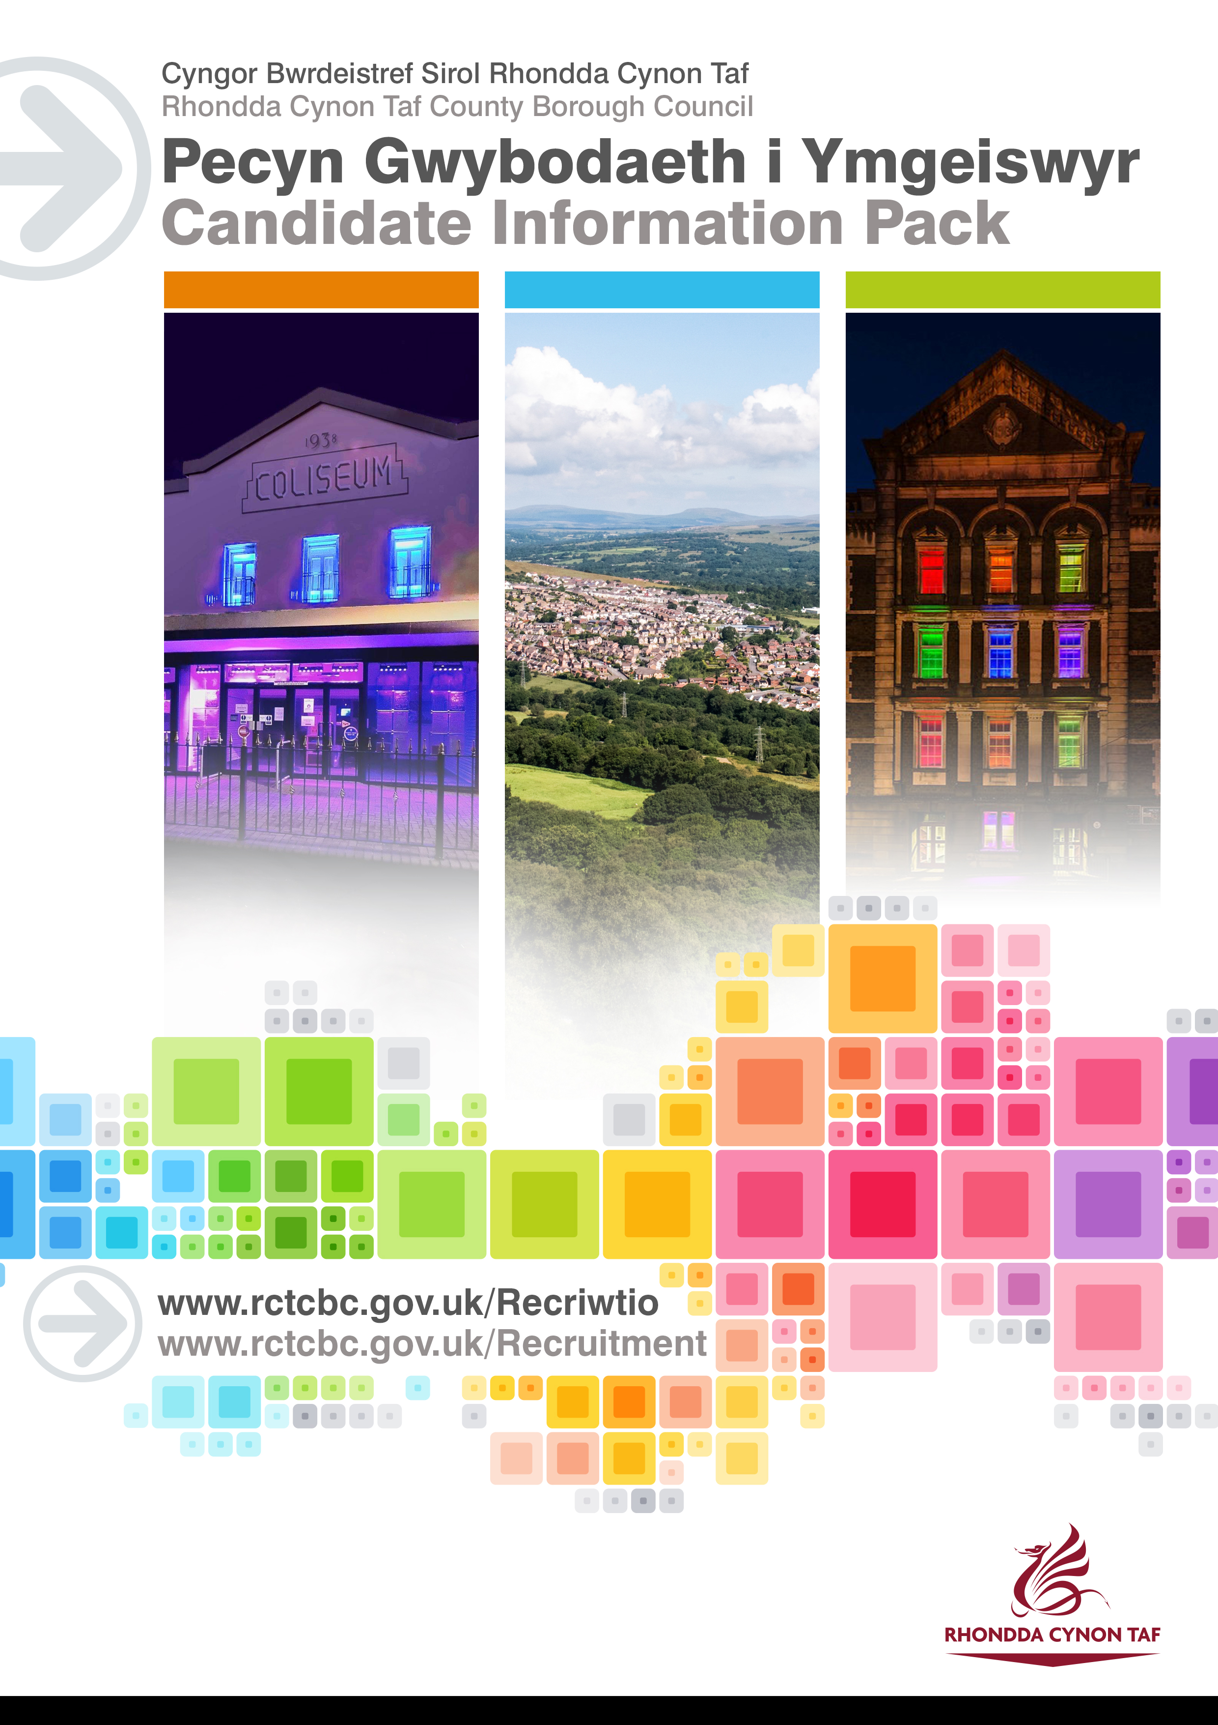
Thank you for your interest in joining our Arts Service. Hopefully, this job pack will give you plenty of information before applying, but if you do have any questions, don’t hesitate to drop us an email on RCTTheatres@rctcbc.gov.uk or TheatrauRCT@rctcbc.gov.uk or call on 01443 425014.

JOB DESCRIPTION

Temporary Full Time Assistant Creative Producer (37 hours)
Post Reference Number: TBC
Date of Job Description: February 2021

 | Salary and Grade | GR 5
 | Location | Remote working / Park & Dare Theatre / Coliseum Theatre

 | Group | COMMUNITY & CHILDREN’S SERVICES
 | Division | PUBLIC HEALTH, PROTECTION & COMMUNITY SERVICES
 | Section | CULTURAL SERVICES

 | DBS Required | YES

Eligibility Criteria

The Weston Jerwood Creative Bursaries programme is on a mission to make the arts more representative. We want to make the sector more representative of the communities that we serve too, and alongside Jerwood Arts we are passionate about making the arts and creative industries sector a more inclusive place to work.

For this reason, this post is targeted at someone who is socio-economically disadvantaged (see next section for further information) and in the early stages of their creative career. This can include a career change from another sector.

We are looking for a creative person who loves to make things happen. You will be passionate about performance, excited to support and develop artists, and be committed to increasing access to and engagement with the arts, particularly for those whose voices have traditionally been unheard.
You will have between 2 – 5 years of work experience since leaving school and may have faced barriers to work previously, so we welcome applications from anyone who may not have taken a traditional route. We recognise there are multiple ways people can experience socio-economic barriers at different stages of their lives, and that these differ from place to place. Applicants do not need to explain in their application how they might fit into these parameters.

The key focus of this programme is to provide an exciting opportunity for someone who has been prevented from pursuing a career in the Arts due to social and economic factors.

We recognise that all types of experience are valuable and provide useful transferable skills so this can be in any work environment; through volunteering; through study at college or university; or independent experience. Your experience does not have to be within the arts and creative industries sector.
We want to play our part in making the arts and cultural sector more inclusive, and ask that all applicants:
- Have the legal right to work in the UK
- Not be in full time education (12 hours or more formal study a week)
- Have between 2-5 years of work experience.
- Have begun to develop your own artistic or creative interests
- Have experienced socio economic disadvantages, such as being from a low income background

If you have experienced any kind of socio economic barriers you may typically have experienced two or more of the following:

- Attended only state-funded school or college;
- Eligibility for free school meals at secondary school;
- The first generation to attend higher education in the family;
- Growing up in a household where at age 14, the primary carer held an occupation
  - that can be described loosely as unemployed;
  - or routine manual and service occupations e.g. van driver, cleaner, porter, waiter/waitress, bar staff;
  - or semi-routine manual and service occupations e.g. postal worker, security guard, machine worker, receptionist, sales assistant.
(these are example jobs rather than a comprehensive list. Other jobs may also be relevant – feel free to ask if you’re not sure.)

We realise that this eligibility can be difficult to understand, and you may be unsure whether you fit the criteria. If you are unsure and would like to discuss further please feel free to contact RCTTheatres@rctcbc.gov.uk or TheatrauRCT@rctcbc.gov.uk or call 01443 425014 to arrange to discuss.

The Weston Jerwood Creative Bursaries programme is designed and run by Jerwood Arts. Watch this video to find out more.
Please read the Weston Jerwood Creative Bursaries Programme ‘One Pager’ which outlines who Jerwood Arts are, how the Weston Jerwood Creative Bursary programme works, and what you will get for the programme beyond the job. Through Weston Jerwood Creative Bursaries programme, you will participate in a professional development programme and be part of a UK wide network of similar posts.
What is a lower socio-economic background?

If you are from a socio-economically disadvantage background, you will most likely have been to state school, might have received free school meals as a child, or had a precarious household income when you were growing up. You might have grown up in the care system, been a young carer, or been the first in your family to go to university. Being from aa socio-economically disadvantaged background means that you are more likely to face interlinked barriers in society, experiencing racism, ableism and other forms of discrimination. You can find out more about socio-economic diversity and inclusion in this Toolkit.

Why join RCT Council’s Arts Service and its RCT Theatres? RCouncil?

RCT Council’s Arts Service is part of the Public Health and Community Services Directorate, alongside Libraries, Welsh Language, Adult Education, Employment Programmes and Community Support.
The service consists of an Arts & Creative Industries Team and RCT Theatres: the Coliseum Theatre, Aberdare and the Park and Dare Theatre, Treorchy.
RCT Theatres is a member of the Arts Council of Wales’ Arts Portfolio Wales and presents on its stages as well as producing and co-producing performance work in-house for our own stages and touring.
In 2019/20, the Park and Dare Theatre, with funding secured from the Council and the Arts Council of Wales, redeveloped its Lounge Bar to create Stiwdio 1, an accessible and flexible space for creating and sharing performance work.
Our Creative Hub at the Park and Dare Theatre offers spaces for our communities to connect, create and share. We are also working closely with our Library Service to enhance this offer and establish a Cultural Hub in Treorchy (part of the Council’s wider Community Hub programme).
We want to bring communities together so that they are connected, resilient and happy.
Our vision is to be a place where everyone belongs; to be a safe creative space for expression, challenge and conversation; and to find and amplify the unheard voices in our communities, making sure that they are reflected in our work.
What we do supports the delivery of the Council’s three priorities:
Ensuring People: are independent, healthy and successful.
Creating Places: where people are proud to live, work and play.
Enabling Prosperity: creating the opportunity for people and business to be innovative, be entrepreneurial; and fulfil their potential and prosper.
As a Council employee, you will have access to a wide range of staff benefits which include:
- 25 days Annual Leave
- Cycle to Work Scheme
- Discounted LeisureForLife Membership
- Vectis Card (staff discount)
- Technology Purchase Scheme

Purpose of the post:

To be a part of the Arts Service and RCT Theatres’ Creative Team, and to engage both with the community and artists to co-create a dynamic programme of work.

What you will deliver:

The Assistant Creative Producer role is a brand new role, starting at a really exciting time for RCT Theatres as we are changing many of the ways we work. We hope that you can bring your skills and experience to shape this role.

We are looking for someone who can:

- Help us achieve our vision for RCT Theatres

- Work with the Theatre Programme and Audience Development Manager and the wider team, to deliver and review our processes and procedures, including contracts, budget monitoring, risk assessments and tour booking.

- Regularly attend meetings about RCT Theatres and the Arts Service.

- Undertake further training and learning.

- Create ways in which to build relationships with and across more of our communities, working with public, private and voluntary sector partners, supporting the development of a Community Engagement Plan for RCT Theatres.

- Support RCT Theatres to create and deliver artistic events that connect to our communities.

- Benefit from undertaking opportunities to include producing, directing, stage management and design.

- Provide the lead on a creative project to be co-created with our communities (you will be fully supported by the Theatre team in this).

- Help us in the evaluation of projects, including evidencing impact and budget monitoring.

- Support us to embed diversity and inclusion across the service.

THE CONTENTS OF THE DOCUMENT WILL BE SUBJECT TO REVIEW FROM TIME TO TIME IN CONSULTATION WITH THE POST HOLDER. JOB DESCRIPTIONS MAY BE AMENDED TO REFLECT AND RECORD SUCH CHANGES.
Protecting Children and Vulnerable Adults is a core responsibility of all staff.
All safeguarding concerns should be reported to the Cwm Taf Multi-Agency Safeguarding Hub (MASH).

PERSON SPECIFICATION
This Person Specification sets out the knowledge and/or qualifications, past experience and personal competencies that would be ideal for this particular post.
The Knowledge/Qualifications and Experience sections describe what is required in terms of the technical ability that is needed to do this job successfully.
The Competencies section describes the kinds of non-technical skills, abilities and personal characteristics that the ideal person for this particular role would have. The competencies describe how that person would ideally work with other people and how they would approach their responsibilities.
The Special Conditions and Professional Requirements section describes any other qualities appropriate to the particular circumstances associated with this role.

Knowledge / Education:
 | Essential | Desirable
 | Welsh Language Level 1 – All employees will be required to undertake a basic Welsh Language Induction to reach this level. Please refer to The Welsh Language Skills Guidance online www.rctcbc.gov.uk/WelshSkills | Welsh Language Level 2 – 5. For guidelines on the levels please refer to the Welsh Language Skills Guidance online www.rctcbc.gov.uk/WelshSkills
 | Knowledge and experience of creative community engagement, theatre and production. | Knowledge of Microsoft Office packages
 | Knowledge of initiating and developing your own creative projects – artistic, skills development and making.
 | Able to communicate effectively, including through the use of social media and digital tools.

What skills you will use in the workplace:

 | Strengths
 | Areas of Strength | Behaviours and values
 | Working with Others | Is a Team Player  Always treats other people with respect
 | Being Committed and Reliable | Is willing to take instruction and advice.. Learns from other team members in order to do the job better  Has a positive attitude towards completing any necessary tasks
 | Communicating Effectively | Listens well to others; understands what they mean, not just what they say  Uses their initiative and can work without close supervision  Is always polite and courteous
 | Professional Expertise and Development | Is positive about continuous professional development (CPD) and seeks opportunities to improve own knowledge.  Takes feedback positively and uses it to develop; learns from mistakes.
 | Creating and Responding to Change | Contributes ideas to better manage systems, processes or practices.  Uses own creative and innovative skills to achieve best results.  Finds ways to use new learning.

Special Conditions and Professional Requirements

To complete the Weston Jerwood Creative Bursary programme and undertake any other training relevant to the role.

Ability to travel independently in line with the requirements of the post and any training required.

Applying

We actively champion and celebrate diversity in all its forms. We positively encourage disabled people, black and non-black people of colour, and people from ethnically diverse backgrounds to apply to join our team.

Please see the Council’s Disability Confident film here: https://www.youtube.com/watch?v=tGTulE6YFJE&feature=youtu.be

To apply you will need to:

Head to https://www.rctcbc.gov.uk/EN/Resident/JobsandTraining/Jobvacancies.aspx to apply. You must fill in the form to apply as no CVs will be accepted.

Please save a copy of your application before applying via the RCTCBC recruitment portal.

You may be eligible to receive support in completing your application through the Communities for Work Team: https://www.rctcbc.gov.uk/EN/GetInvolved/CommunitiesforWorkPlusCfW/CommunitiesforWorkPlusCfW.aspx

You may also find this tool useful in completing you application: https://www.youtube.com/watch?v=AEF_vlw-VZw&feature=emb_imp_woyt

Interview

If your application is shortlisted and you are invited to interview, we want you to be able to talk about yourself and your work experience in a relaxed and friendly setting.

We aim to make the interviews as accessible and engaging as possible.

We feel an interview is a chance for you to find out more information about the role and to get a sense of whether this is the right environment for you.

We will send a list of the areas that we will focus on at the interview in advance of the interview and of course, please let us know in advance if you have any special requirements or needs we might want to consider.

