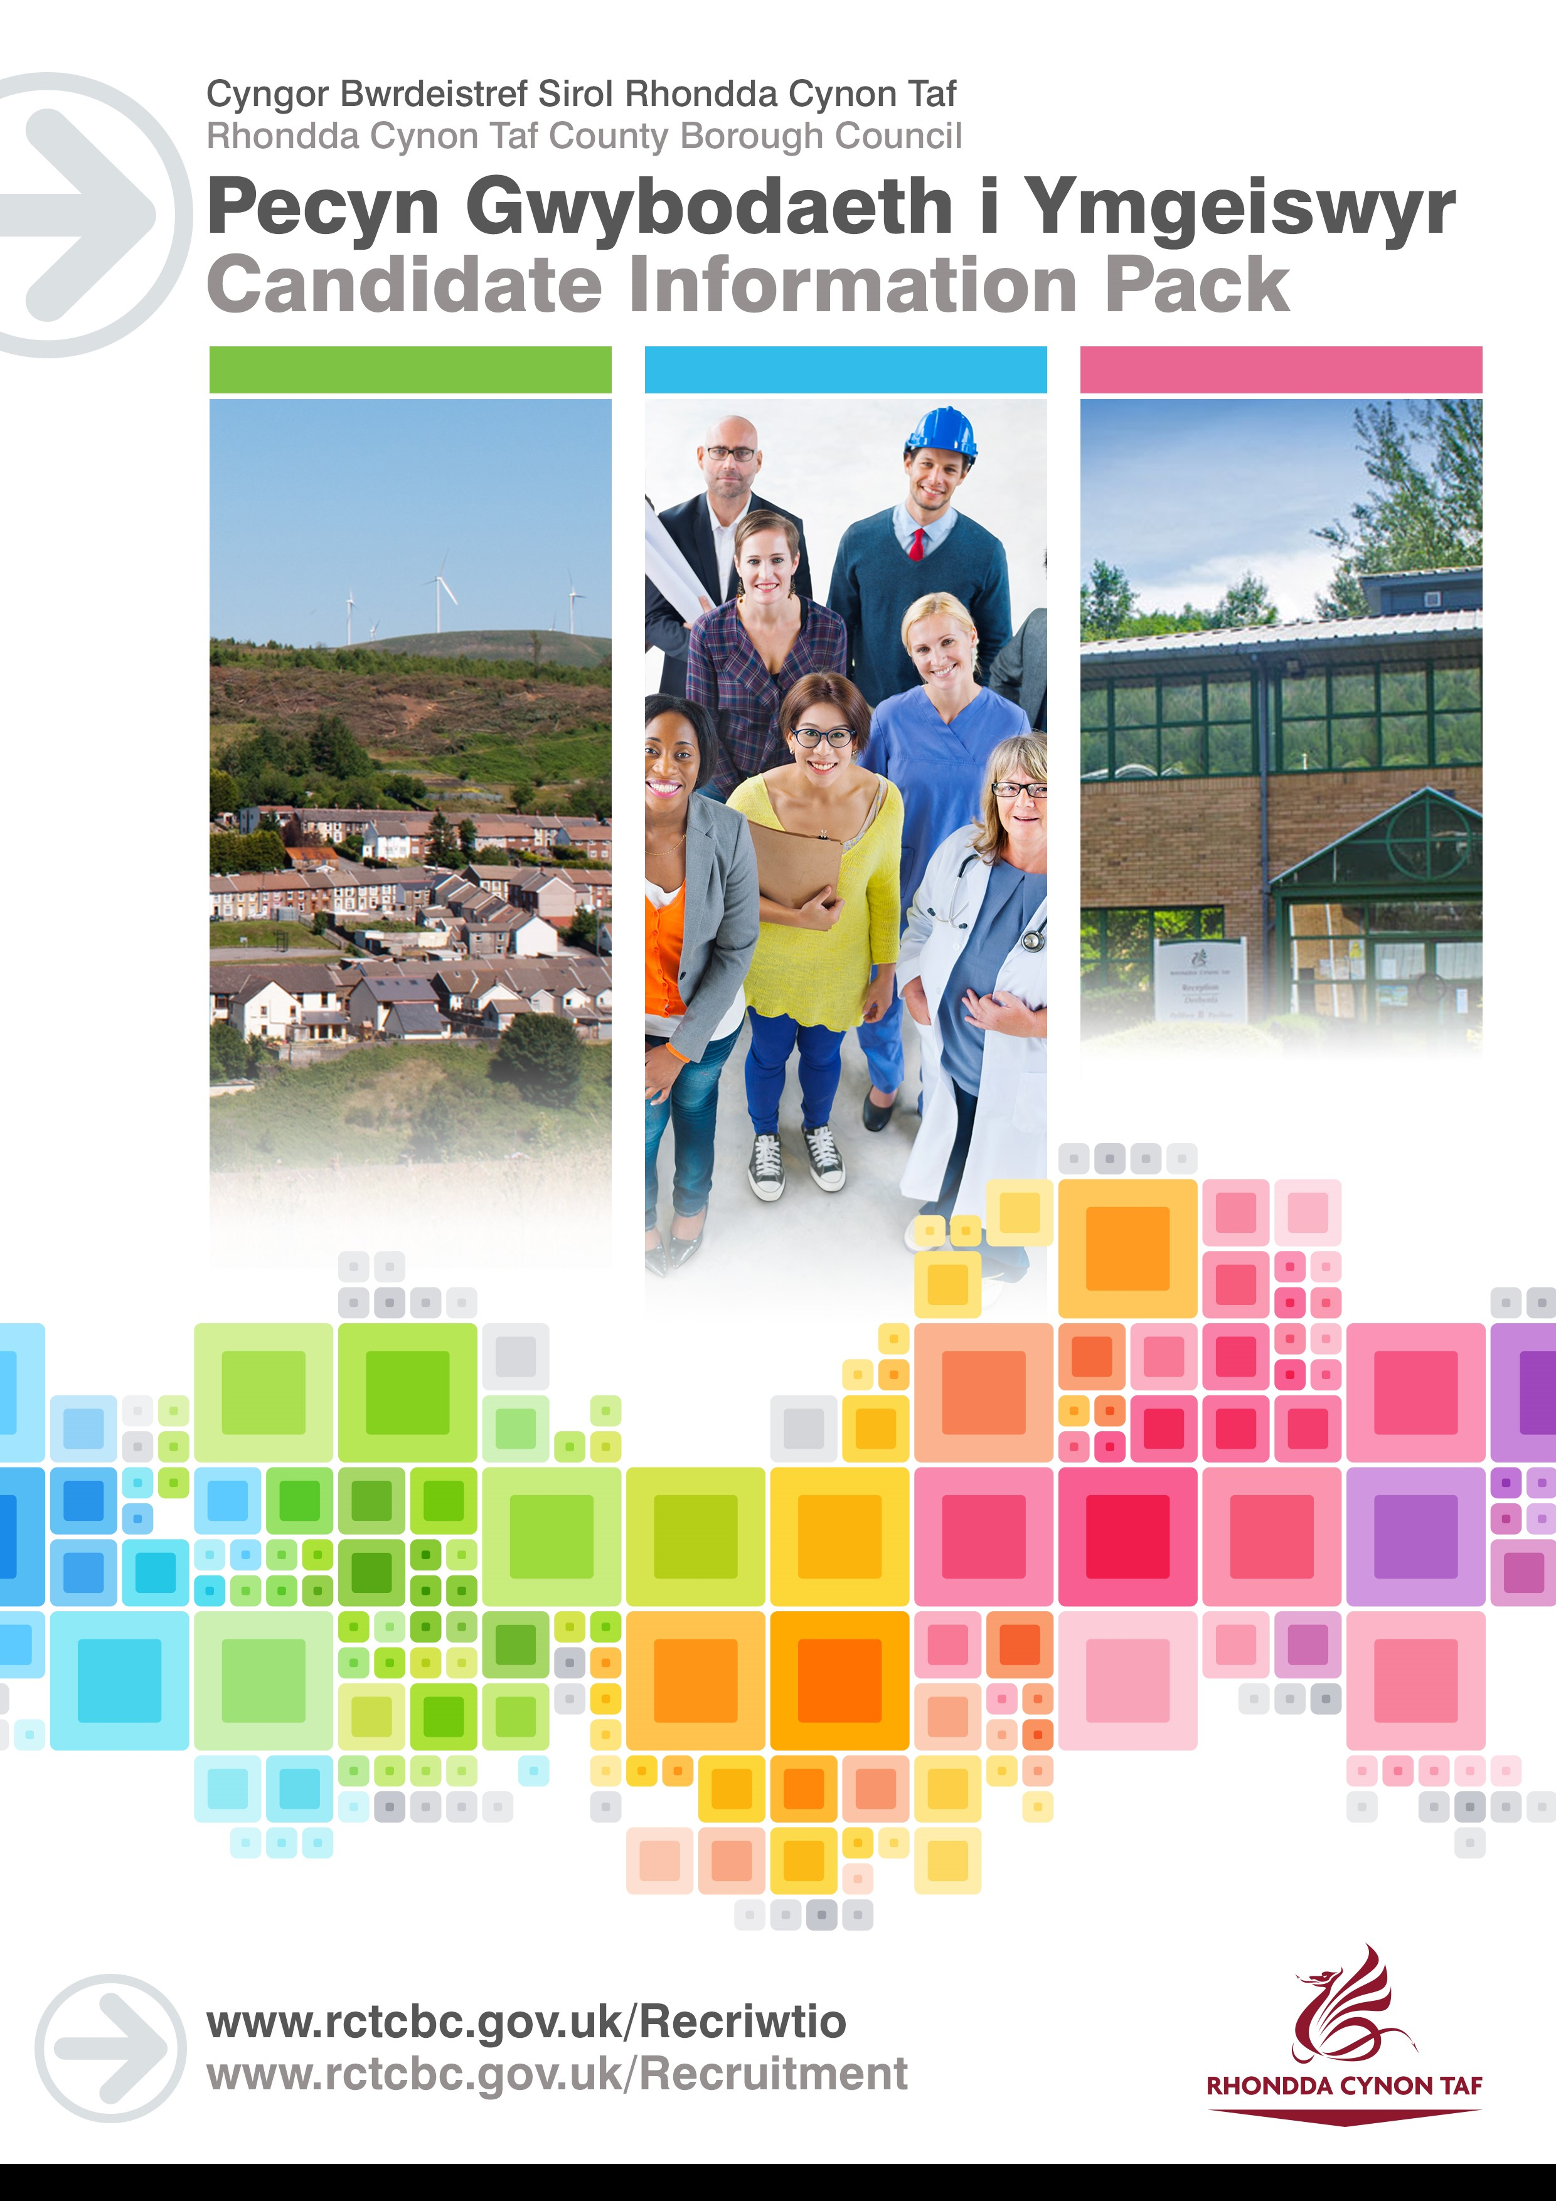
JOB DESCRIPTION

Temporary Apprentice Miskin Intervention Support Worker
Post Reference Number: TBC
Date of Job Description: September 2020

 | Salary and Grade | National Minimum Wage
 | Location | Glyncornel Centre, Llywnypia

 | Group | Community & Children’s Services
 | Division | Children’s Services
 | Section | Early Intervention

 | DBS Required | Yes, Enhanced

Why have an Apprenticeship with RCT Council?

RCT Council’s award winning Apprenticeship Scheme has been running since 2012. In that time we have employed over 200 apprentices across a variety of services.
During an Apprenticeship with RCT, you will work alongside experienced Council Officers, gaining job-specific knowledge and skills. Apprenticeships mix on-the-job training with classroom learning. They provide you with the skills you need for your chosen career that will also lead to nationally recognised qualifications. As an Apprentice you will earn while you learn, we pay National Minimum Wage.
RCT Council Apprentices also have access to a wide range of staff benefits which include:
- 25 days Annual Leave
- Cycle to Work Scheme
- Discounted LeisureForLife Membership
- Vectis Card (staff discount)
- Technology Purchase Scheme
To find out more about RCT Council’s Apprenticeship Scheme and how to complete our application form visit our platform via the following link: https://www.rctcbc.gov.uk/EN/Resident/JobsandTraining/ApprenticeshipandGraduateScheme/ApprenticeshipandGraduateScheme.aspx

Purpose of the post:

To contribute to the achievement of the objectives and performance targets of the department.

To help young people, families and carers stay together; by supporting placement stability for young people within Rhondda Cynon Taf.

To assist in the provision of effective Miskin interventions by Transporting children/young people/families to programme venues.

To enhance the quality of lives of young people in Rhondda Cynon Taff by assisting provide a range of outdoor activities, leisure activities on a group work basis.

What you will deliver:

To attend and take part in regular team meetings and regular reviews with line manager etc.
To work in a professional manner and portray a positive image of the Miskin Project and Rhondda Cynon Taf County Borough Council.

To work with Miskin caseworkers in encouraging and supporting parents/carers, and working directly with children and young people, by assisting transport users supported by the Miskin Project to designated venues and collect for the return journey.

To assist maintain Miskin equipment stores in a clean state and good working order.

To assist in the maintenance, storage and preparation of outdoor pursuits equipment.

To assist with the monitoring of the use of equipment (i.e. booking in and out of equipment lent to others, logging the use of safety equipment etc.)

To assist Outdoor Adventure Activity Leaders within Miskin undertake activities with children and young people.

To assist the group leader with the transportation and application of safety equipment, where appropriate and under the supervision of the activity instructor.

To assist with the supervision of overnight or weekend offsite residential or camping expeditions with groups of young people when required.

To undertake one to one direct work and lead group activities with children and young people in activitiies that appropriate qualifications and/or experience is held.

To offer support to children and young people to develop self esteem, social skills and leisure interests.

To bring to the attention of the Miskin caseworker, Senior Practitioner or Consultant Social Worker any immediate concerns regarding the safety of a child or young person.

To ensure work is completed in accordance with the agreed schedule or as directed by a Line Manager.

To receive regular supervision in accordance with Divisional guidelines.

To participate in training and staff development programmes as thought appropriate by the Line Manager in order to keep abreast of new developments and thinking.

To provide a service which is anti-discriminatory on grounds of race, sex, age, marital status, sexual orientation, disability, religion or nationality.

Ability to work flexibily in a family supportive manner.

To carry out health and safety responsibilities in accordance with the Division’s Health & Safety Responsibilities document.
To undertake such other duties and responsibilities commensurate with the grade, as may be reasonably required by the Service Director, or as a mutually agreed development opportunity.
THE CONTENTS OF THE DOCUMENT WILL BE SUBJECT TO REVIEW FROM TIME TO TIME IN CONSULTATION WITH THE POST HOLDER. JOB DESCRIPTIONS MAY BE AMENDED TO REFLECT AND RECORD SUCH CHANGES.
Protecting Children and Vulnerable Adults is a core responsibility of all staff.
All safeguarding concerns should be reported to the Cwm Taf Multi-Agency Safeguarding Hub (MASH).

PERSON SPECIFICATION
This Person Specification sets out the knowledge and/or qualifications, past experience and personal competencies that would be ideal for this particular post.
The Knowledge/Qualifications and Experience sections describe what is required in terms of the technical ability that is needed to do this job successfully.
The Competencies section describes the kinds of non-technical skills, abilities and personal characteristics that the ideal person for this particular role would have. The competencies describe how that person would ideally work with other people and how they would approach their responsibilities.
The Special Conditions and Professional Requirements section describes any other qualities appropriate to the particular circumstances associated with this role.
Knowledge / Education:
 | Essential | Desirable
 | Welsh Language Level 1 – All employees will be required to undertake a basic Welsh Language Induction to reach this level. Please refer to The Welsh Language Skills Guidance online www.rctcbc.gov.uk/WelshSkills | Welsh Language Level 2 – 5. For guidelines on the levels please refer to the Welsh Language Skills Guidance online www.rctcbc.gov.uk/WelshSkills
 |  | Have experience of participating in outdoor adventurous activities e.g. canoeing/kayaking, rock climbing, caving, hill walking, mountain biking etc or other sports. Although not essential, candidate would be required to fully engage in all aspects of a group work programme in the outdoors to support and encourage young people.
 |  | Ability to drive and possession of a full driving licence.
 |  | Outdoor pursuits or sports coach qualifications.
 |  | Youth work qualification.

Experience:
 | Essential | Desirable
 | Have experience of or an interest in developing experience of working with children & young people and be committed to wanting to make a real difference to young people’s lives and act as a positive adult role model. | Experience of working with families of children and young people.

What skills you will use in the workplace:

 | Competency Framework | Community & Social Care Competency
 | Competency Areas | Competency behaviours and values
 | Working with Team Members | Builds lasting, positive & supportive relationships based on trust  Recognises that all members of the team have a different skills and experience that can be drawn on  Contributes to a strong team spirit of shared responsibility and co-operation
 | Communicating Effectively | Communicates clearly and concisely  Genuinely listens to others' views, openly considering what they are saying
 | Complying with Health & Safety | Is aware of all relevant H&S procedures  Is aware of current and potential risks and hazards within the context of their duties  Puts measures in place that minimise risk of incidents  Always reports any risks or incidents to the correct people

Special Conditions and Professional Requirements

To complete the Apprenticeship Framework and undertake any other training relevant to the role including coaching from a supervisor and on the job training.

To sign a learning contract with the training provider/college and adhere to the agreement.

Ability to travel independently in line with the requirements of the post and any training required.

Have the ability to communicate sensitively with young people and their families.

Enhanced Disclosure and Barring checks on appointment and at periodic intervals.

Miskin staff will be required to work in family supportive manner, therefore, must be able and willing to be flexible in their hours of work. e.g. early mornings, evenings, occasional weekends, school holidays and occasional multi-day residential trips.

The role involves working within the safeguarding arena with vulnerable young people, as well as in the outdoors environment engaging young people in outdoor adventurous activities and where personal resilience, maturity of judgement as well as being able to work within strict codes of confidentiality is essential. Consequently, post holder must be minimum age 19 year olds.

