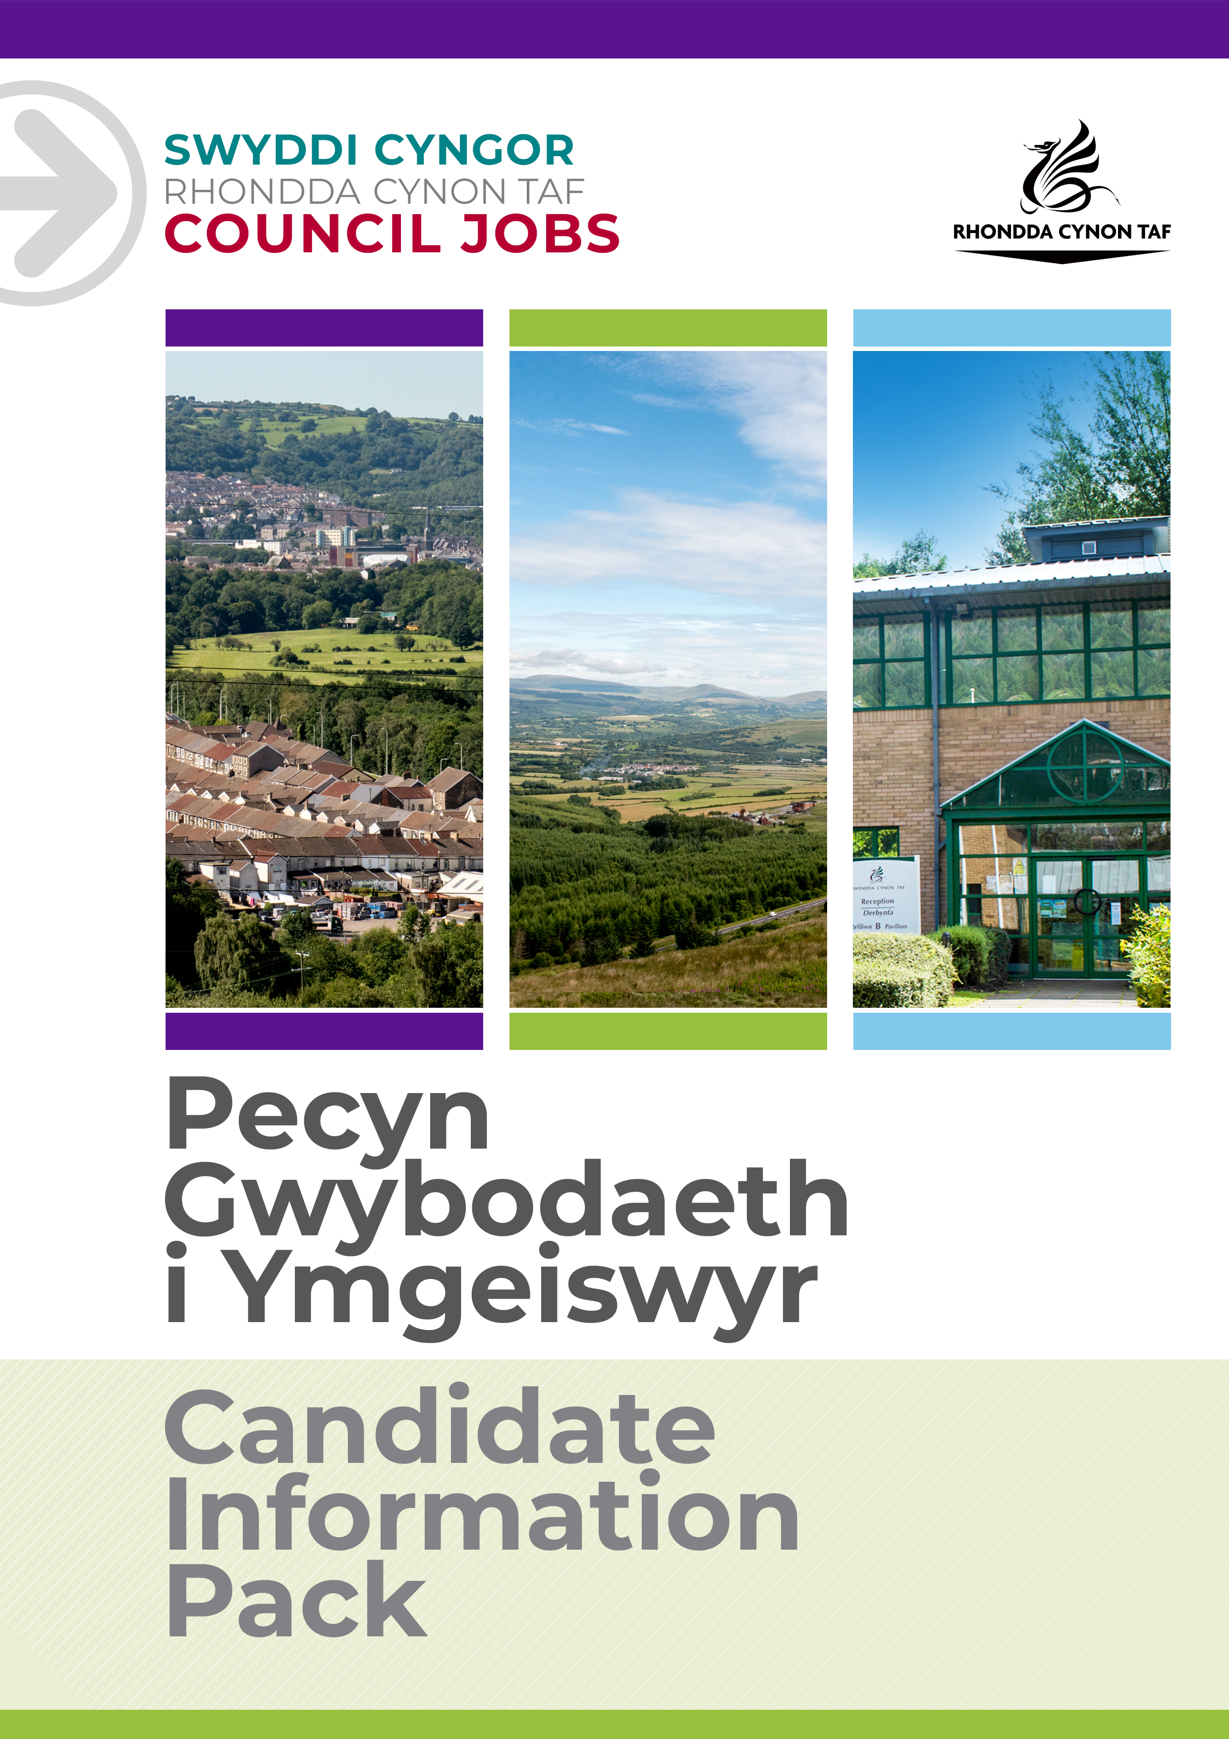
JOB DESCRIPTION
Mobile security guard
Post Reference Number: POST014284
Date of Job Description: 15/11/22
Version:1

 | Grade | GR4
 | Location | CCTV Control Centre Ty Elai CF401NY

 | Group | Community and Children’s Services
 | Division | Public Health, Protection and Community Services
 | Department/Section | Community Safety
 | Team/Sub Section | CCTV

 | Responsible to | Senior CCTV Officer
 | Posts reporting to this post

 | DBS Required | Yes Standard

Why work for Rhondda Cynon Taf Council?

Rhondda Cynon Taf Council is one of the largest Local Authorities in Wales and our vision is “for Rhondda Cynon Taf to be the best place in Wales to live, work and play, where people and businesses are independent, healthy and prosperous”.
If you work for us, everything you do will be about making a positive difference to our community and the public sector.
Our excellent induction, training and development programmes will help you grow in your role. You will be challenged and supported, with the opportunity to learn new and transferable skills whilst playing your part in helping others.
Our generous annual leave allowance will provide you with 25 days holidays (pro rata, increasing to 30 upon 5 years of completed service), in addition to 8 public holidays. We have an excellent pension scheme with employer contributions and our financial support benefits will help to give you a sense of security and wellbeing for the future. We care about the wellbeing of our staff and our family friendly and inclusive policies allow for flexibility when needed. We offer support and advice including counselling, health surveillance, nurse and physiotherapy services. There are also a number of staff networks for employees including the Allies Network, a Disability and Carers Network, Perthyn our LGBTQ+ Network and Spotlight, open to Black, Asian and minority ethnic staff.
In addition, you will have access to a wide range of staff benefits including discounted ‘Leisure for Life’ membership, ‘Vectis Card’ for discounts on hundreds of products and services, Cycle to Work scheme and a technology purchase scheme.
Please see our career pages to find out more about working for us.

Purpose of the post:

- To support the Senior CCTV Officer in the delivery of Security Services Within Rhondda Cynon Taf County Borough Council.
- To provide efficient and high quality Security Services in Rhondda Cynon Taf.

What you will deliver:

- To contribute to the achievement of the objectives and performance targets as set out in the relevant Plans for the CCTV/Security Section.
- To undertake site visits, mobile patrols, building checks and site security assesments.
- Respond to alarm activations as directed by the control room staff.
- To comply with current key holder proceedures and ensure key, codes and fobs are secure and accounted for.
- Maintain acurate log book entries and make available when required.
- Communicate effectivly with operational staff within the CCTVcontrol centre and report all incidents of a suspicious or criminal nature.
- Liaise and assist Police, and other authorised emergency agencies as and when required.
- To assist officers with statements and provide evidence in court as a witness if required.
- To ensure the security vehicle is kept in a neat and clean condition.
- To Ensure personal equipments and uniform is maintained and in good working condition.
- To maintain personal integrity and confidentiality of all information obtained within post, whether written, verbal, or recorded by any other means.
- To accurately record all alarms and activities onto the database.
- To be flexible and receptive in accepting changes to shift patterns/rotas, subject to a notice period of 7 days.
- To ensure the alarm monitoring room is kept in a neat and clean condition.
15.To undertake any training relevant to the post.

To undertake such other duties and responsibilities commensurate with the grade, as may be reasonably required by the Service Director, or as a mutually agreed development opportunity.
To comply with the Council’s Health and Safety Policies and procedures and undertake any relevant health and safety duties in accordance with local arrangements.
To support the Council to play its part in tackling Climate Change and meeting its Carbon Reduction targets across the services it delivers and also in the goods and services it buys or commissions from other organisations.
All staff have a valuable and vital role in keeping people safe. Any person with concerns regarding the safety of a child or adult at risk, OR the behaviour of a colleague towards a child or adult at risk, has a responsibility to report this immediately. This should be done via the person’s Line Manager, Designated Safeguarding Lead or contact the Cwm Taf Multi Agency Safeguarding Hub.

THE CONTENTS OF THE DOCUMENT WILL BE SUBJECT TO REVIEW FROM TIME TO TIME IN CONSULTATION WITH THE POST HOLDER. JOB DESCRIPTIONS MAY BE AMENDED TO REFLECT AND RECORD SUCH CHANGES.

PERSON SPECIFICATION
This Person Specification sets out the knowledge and/or qualifications, past experience and personal competencies that would be ideal for this particular post.
The Knowledge/Qualifications and Experience sections describe what is required in terms of the technical ability that is needed to do this job successfully.
The Competencies section describes the kinds of non-technical skills, abilities and personal characteristics that the ideal person for this particular role would have. The competencies describe how that person would ideally work with other people and how they would approach their responsibilities.
The Special Conditions and Professional Requirements section describes any other qualities appropriate to the particular circumstances associated with this role.
Knowledge / Education:
 | Essential | Desirable
 | Commitment to undertake a Security Industry Authority (SIA) | Security Industry Authority (SIA) Examinations
 |  | Public Space Surveillance (CCTV) Licence

Experience:
Essential | Desirable
Essential
Dealing with Customers and partner agencies, including good communication skills | Experience of using database systems
Using a range of IT applications (including Microsoft Suite) | Awareness of the Human Rights & Data Protection Act.
Working in a team environment

Welsh language skills:
 | Essential | Desirable
 | Welsh Language Level 1 ☒  All employees will be required to undertake a basic Welsh Language induction to reach this level  Welsh Language Level 2 ☐  Welsh Language Level 3 ☐  Welsh Language Level 3-5 ☐  Welsh Language Level 4 ☐  Welsh Language Level 5 ☐ | Welsh Language Level 2 ☒  Welsh Language Level 3 ☐  Welsh Language Level 3-5 ☐  Welsh Language Level 4 ☐  Welsh Language Level 5 ☐
 | For details about the levels please refer to ‘The Welsh Language Skills Guidance’ online: www.rctcbc.gov.uk/WelshSkills

What skills you will use in the workplace:

 | Competency Framework | Technical, Specialist and Professional Framework
 | Competency Areas | Competency behaviours and values
 | Working in Partnerships and Teams | Builds lasting, positive and supportive relationships with a wide variety of people.  Draws upon the best ideas of the team to provide the best service.
 | Communicating Effectively | Communicates clearly and concisely  Cascades and shares information appropriately - on time and to the right people
 | Managing Resources | Plans well in advance to meet deadlines
 | Achieving Results | Consistently meets deadlines.  Is proactive and flexible to changing demands and knows when to compromise.
 | Focusing on Service Users  Creating and Responding to Change  Being accountable | Is very approachable and encouraging to customers, whilst remaining professional and unbiased.  Uses professional knowledge and expertise to raise standards of service for customers.  Responds quickly and effectively to both internal and external changes.  Uses own creative and innovative skills to achieve best results.  Is always open, honest, and transparent.  Takes full responsibility for delivery of tasks.

Special Conditions and Professional Requirements

To have the ability to travel throughout the County Borough.

Sign a confidentiality agreement dealing with the necessary requirements to maintain safe and secure operations.

