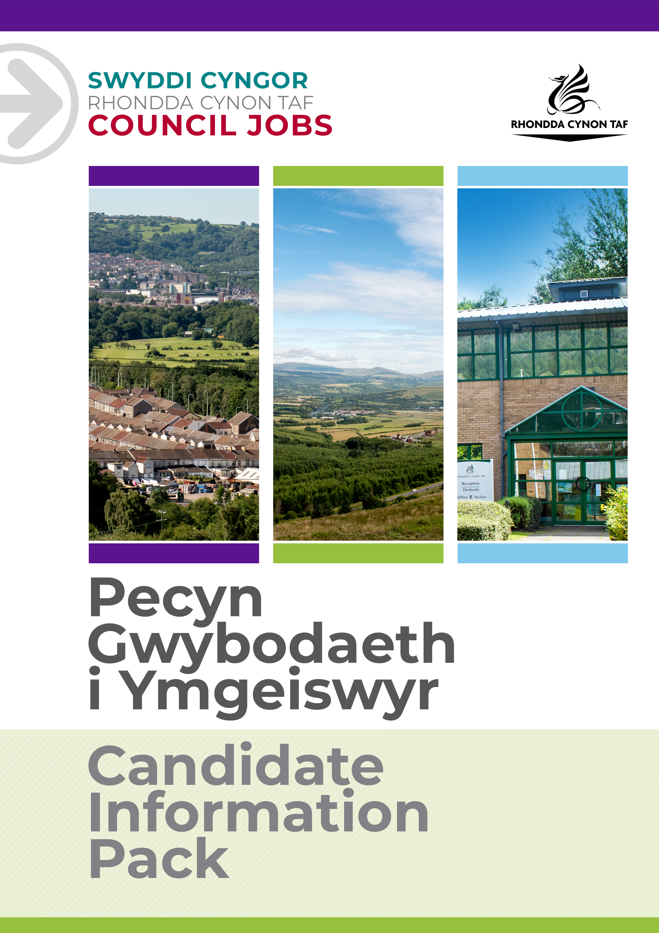
JOB DESCRIPTION

NATIONAL ENGAGEMENT, PARTICIPATION AND CONSULTATION OFFICER

Post Reference Number:
Date of Job Description:
Version:

 | Grade | 11
 | Location | Valleys Innovation Centre

 | Group | Community & Children’s Services
 | Division | Children's Commissioning Consortium Cymru
 | Department/Section
 | Team/Sub Section | Young Commissioners

 | Responsible to | National Strategic Commissioning Officer
 | Posts reporting to this post | N/A

 | DBS Required | YES – ENHANCED CHILDREN’S WORKFORCE

Why work for Rhondda Cynon Taf Council?

Rhondda Cynon Taf Council is one of the largest Local Authorities in Wales and our vision is “for Rhondda Cynon Taf to be the best place in Wales to live, work and play, where people and businesses are independent, healthy and prosperous”.
If you work for us, everything you do will be about making a positive difference to our community and the public sector.
Our excellent induction, training and development programmes will help you grow in your role. You will be challenged and supported, with the opportunity to learn new and transferable skills whilst playing your part in helping others.
Our generous annual leave allowance will provide you with 25 days holidays (pro rata, increasing to 30 upon 5 years of completed service), in addition to 8 public holidays. We have an excellent pension scheme with employer contributions and our financial support benefits will help to give you a sense of security and wellbeing for the future. We care about the wellbeing of our staff and our family friendly and inclusive policies allow for flexibility when needed. We offer support and advice including counselling, health surveillance, nurse and physiotherapy services. There are also a number of staff networks for employees including the Allies Network, a Disability and Carers Network, Perthyn our LGBTQ+ Network and Spotlight, open to Black, Asian and minority ethnic staff.
In addition, you will have access to a wide range of staff benefits including discounted ‘Leisure for Life’ membership, ‘Vectis Card’ for discounts on hundreds of products and services, Cycle to Work scheme and a technology purchase scheme.
Please see our career pages to find out more about working for us.

Purpose of the post:

To develop the Young Commissioners Group (YCG), Young Commissioners Voices Board (YCV) and their work programme, promoting engagement and inclusion by care experienced children and young people living across all 22 local authority areas in Wales.
To manage a high quality innovative engagement service, promote a Child's Rights approach and maximise the impact of the Voice of the Child at the centre of the Consortium's work and related national projects.
To commission and contract monitor services required to support the delivery of the YCG.
To manage, develop and advise on the delivery of the Young Commissioners Accredited Qualification across Wales.
To maintain the Team’s accreditation of the National Participation Standards and grow the reputation of the Team’s engagement, participation and co productive work with the YCG.
To design and deliver high quality consultation exercises with the YCG.

What you will deliver:

1. To be responsible for working alongside the National Commissioning Officer to lead the development and delivery of the YCG and YCV.
2. To oversee the management of engagement, participation and consultation aspects of service wide delivery across the Consortium membership, working closely with both Local Authorities and Providers, including ensuring the service is available through the medium of Welsh.
3. To develop an innovative and modern toolkit of resources to optimise service user access.
4. To oversee the appropriate recruitment and supervision of casual staff to support the YCG work programme as required on behalf of the Team, ensuring all Team and relevant Council policies and procedures are complied with.
5. To commission external providers to support activities and consultations with the YCG as required on behalf of the Team, to monitor the delivery and quality of the service delivered meets contracted expectations, and ensuring all Team and relevant Council policies and procedures are complied with.
6. To be responsible for the implementation and monitoring of the YCG work programme, providing quarterly performance updates to the National Commissioning Officer and an annual report.
7. Provide and present detailed reports (qualitative and quantitative) on the consultation work with the YCG, for the 4Cs Board and other national organisations as required and to recommend changes in practice as necessary.
8. Commission, edit and present a varied range of mixed media based communications with the YCG to raise awareness of their priorities, influence practice and recommend improvements or alternative ways of working to maximise a Child's Rights approach as necessary.
9. To design and oversee the delivery of targeted work with children and young people to build consultation resources relevant to national thematic projects linked to care experience.
10. To oversee the effective delivery of a comprehensive YCG open access offer for children and young people cared for in Wales by Consortium members that supports the Consortium's statement of purpose, building membership in under- represented areas with an inclusive approach.
11. To have responsibility for budget planning and management of the YCG budget liaising with the Business Support Officer and reporting to the Strategic Commissioning Officer, including negotiating supplier rates, reconciliation of spend and identifying grant funded opportunities to supplement the allocated annual budget.

12. To resolve issues that may arise with the professional teams supporting the YCG in the first instance, escalating issues to the National Commissioning Officer as appropriate
13. To oversee Safeguarding, Confidentiality and GDPR processes across the YCG, ensuring that the Service operates within Council policy and relevant legislation at all times.
14. Take a proactive approach to engaging a range of partners in the delivery of the YCG events and work programme, specifically forming positive working relationships with local Participation Officers to ensure the national offer complements and supports local offers of engagement, participation and consultation.
15. Plan and support the links between the YCV Board and 4Cs Board to promote delivery of mutual priorities.
16. Embed the Accredited Qualification, increasing the number of YCG that engage in the qualification and successfully complete the modules, coordinating assessor training and assessor availability with Consortium Members and key partners in programme delivery.
17. To support the Team and Consortium members to work effectively with a Child's Right approach to all aspects of their work.
18. To work alongside the Contract Monitoring Officers to support engagement of children and young people in quality assurance processes across the Team, staying up to date with new technologies which may prove to be positive media's for engagement, participation and consultation as part of quality assurance.
19. To develop and implement a comprehensive communication strategy for the YCG and YCV.
20. To ensure that all quality assurance mechanisms, safeguarding and health and safety policies and procedures are adhered to at all times.
21. To develop and maintain a successful leaving care / transitions peer support group for our Young Commissioners who are aged 16 plus.
22. To take personal responsibility for keeping up to date with national guidance, changes to legislation and new strategies which might impact on this role
To undertake such other duties and responsibilities commensurate with the grade, as may be reasonably required by the Service Director, or as a mutually agreed development opportunity.
To comply with the Council’s Health and Safety Policies and procedures and undertake any relevant health and safety duties in accordance with local arrangements.
To support the Council to play its part in tackling Climate Change and meeting its Carbon Reduction targets across the services it delivers and also in the goods and services it buys or commissions from other organisations.
All staff have a valuable and vital role in keeping people safe. Any person with concerns regarding the safety of a child or adult at risk, OR the behaviour of a colleague towards a child or adult at risk, has a responsibility to report this immediately. This should be done via the person’s Line Manager, Designated Safeguarding Lead or contact the Cwm Taf Multi Agency Safeguarding Hub.

THE CONTENTS OF THE DOCUMENT WILL BE SUBJECT TO REVIEW FROM TIME TO TIME IN CONSULTATION WITH THE POST HOLDER. JOB DESCRIPTIONS MAY BE AMENDED TO REFLECT AND RECORD SUCH CHANGES.

PERSON SPECIFICATION
This Person Specification sets out the knowledge and/or qualifications, past experience and personal competencies that would be ideal for this particular post.
The Knowledge/Qualifications and Experience sections describe what is required in terms of the technical ability that is needed to do this job successfully.
The Competencies section describes the kinds of non-technical skills, abilities and personal characteristics that the ideal person for this particular role would have. The competencies describe how that person would ideally work with other people and how they would approach their responsibilities.
The Special Conditions and Professional Requirements section describes any other qualities appropriate to the particular circumstances associated with this role.
Knowledge / Education:
 | Essential | Desirable
 | Degree in Youth and Community Work (or equivalent) / Post Graduate Diploma in Youth and Community Work (or equivalent)  Sound knowledge and understanding of the relevant policy and legislative framework regarding statutory social services.  Sound knowledge of engagement, participation and consultation practice with Children and Young People.  Welsh Language Level 2- Level 5. Please refer to The Welsh Language Skills Guidance online www.rctcbc.gov.uk/WelshSkills | Management qualification  Evidence of continuing professional development.  Accredited Assessor in ASDAN or equivalent courses.  Training in ACEs / Trauma Informed Care or equivalent
Experience:
 | Essential | Desirable
 | Experience of working in Youth Work or Children Services.  Budget monitoring and management.  Multi-agency working.  Strategic programme planning.  Managing complex projects.  Experience of developing strategies to improve engagement, participation and consultation. | Experience of delivering staff training.  Experience of national project delivery.

Welsh language skills:
 | Essential | Desirable
 | Welsh Language Level 2 ☒  All employees will be required to undertake a basic Welsh Language induction to reach this level | Welsh Language Level 2 ☒  Welsh Language Level 3 ☒  Welsh Language Level 3-5 ☒  Welsh Language Level 4 ☒  Welsh Language Level 5 ☒
 | For details about the levels please refer to ‘The Welsh Language Skills Guidance’ online: www.rctcbc.gov.uk/WelshSkills

What skills you will use in the workplace:

 | Competency Framework | Community and Social Care Framework
 | Competency Areas | Competency behaviours and values
 | Working With Partners | Works to overcome conflicting viewpoints for the best interest of the Service User.  Actively identifies partners and community networks that can be used for the benefit of the service user
 | Working with Team Members | Builds lasting, positive & supportive relationships based on trust  Recognises that all members of the team have different skills and experiences that can be drawn on
 | Communicating Effectively | Genuinely listens to others’ views, openly considering what they are saying.  Uses style of language that others (e.g. children, young people, community representatives, managers, professionals), can clearly understand.  Consistently uses the form of communication that is best for the situation (e.g. verbal, email, writing)
 | Earning Service Users’ Trust | Respects Service Users’ individuality, feelings and beliefs, their rights to privacy and to make choices.  Establishing two way communication that respects the rights and beliefs of the individual e.g. rapport
 | Working with Change | Has creative and different ideas about how to move things forward in service areas.  Makes changes and ideas a reality, and helps to make them work
 | Looking after the Service Users Best Interest | Listens to the views of the service user, and includes those involved with the service users, to define the best ways forward.  Is able to look broadly at the options possible and works alongside the service users to seek out possibilities  Works with individuals to assess their needs and preferences within the organisational constraints
 | Achieving Results | Is positive and creative about what can be achieved with existing resources/budgets.  Is flexible, can switch tasks / roles / priorities to deal with new demands, changes or new information
Special Conditions and Professional Requirements

Flexible working arrangements, will require some evening and weekend working and school holidays.

Competent ICT skills

The postholder will need to travel independently throughout Wales to deliver projects.

