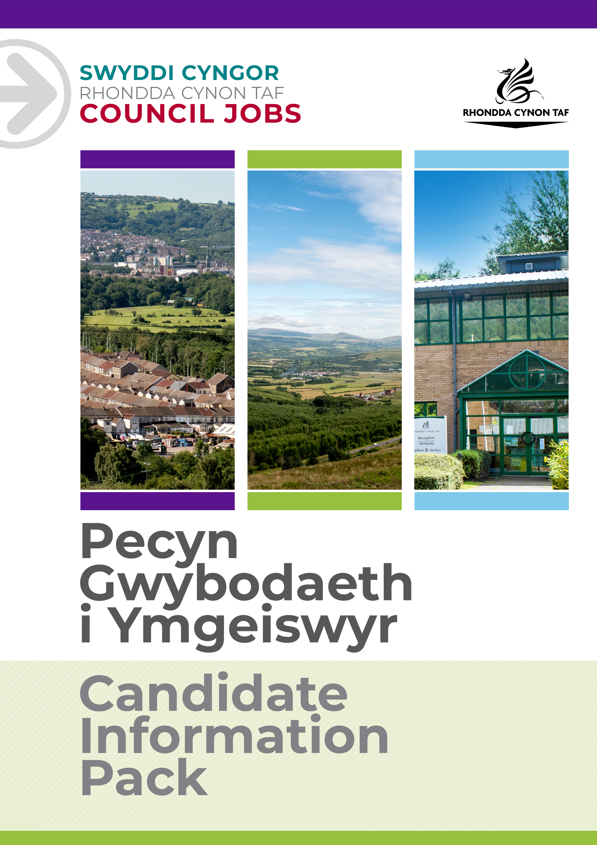
JOB DESCRIPTION

We have an exciting opportunity in Rhondda Cynon Taf to join our Life Journey Team as a support worker who will work closely with Children’s Social Workers providing life journey work for children and young people whose plan is adoption.

Post Reference Number: POST016778
Date of Job Description: AUGUST 2022
Version:

 | Grade | GRADE 5
 | Location | TY TREVITHICK & RHONDDA PRINCIPAL OFFICE

 | Group | COMMUNITY & CHILDREN’S SERVICES
 | Division | CHILDREN’S SERVICES
 | Department/Section | SAFEGUARDING AND SUPPORT
 | Team/Sub Section | LIFE JOURNEY TEAM

 | Responsible to | PRINCIPAL SOCIAL WORKER
 | Posts reporting to this post | NONE

 | DBS Required | YES/ENHANCED

Why work for Rhondda Cynon Taf Council?

Rhondda Cynon Taf Council is one of the largest Local Authorities in Wales and our vision is “for Rhondda Cynon Taf to be the best place in Wales to live, work and play, where people and businesses are independent, healthy and prosperous”.
If you work for us, everything you do will be about making a positive difference to our community and the public sector.
Our excellent induction, training and development programmes will help you grow in your role. You will be challenged and supported, with the opportunity to learn new and transferable skills whilst playing your part in helping others. Our generous annual leave allowance will provide you with 25 days holidays (pro rata, increasing to 30 upon 5 years of completed service), in addition to 8 public holidays. We have an excellent pension scheme with employer contributions and our financial support benefits will help to give you a sense of security and wellbeing for the future. We care about the wellbeing of our staff and our family friendly and inclusive policies allow for flexibility when needed. We offer support and advice including counselling, health surveillance, nurse and physiotherapy services. There are also a number of staff networks for employees including the Allies Network, a Disability and Carers Network, Perthyn our LGBTQ+ Network and Spotlight, open to Black, Asian and minority ethnic staff.
In addition, you will have access to a wide range of staff benefits including discounted ‘Leisure for Life’ membership, ‘Vectis Card’ for discounts on hundreds of products and services, Cycle to Work scheme and a technology purchase scheme.
Please see our career pages to find out more about working for us.

Purpose of the post:

Manager to complete
To assist in the provision of life journey work for children, working closely with the child’s social worker, the senior practitioner for adoption in RCT and VVC regional co-ordinator for life journey work.
To safeguard and promote the wellbeing of vulnerable children and young people.
To work with children, families, carers and other agencies to ensure all the required information is available to enable the child and adopter to understand the child’s life journey.
To main the highest professional standards in the discharge of this post and to up hold the Social Care Wales Code of Professional Practice.

What you will deliver:

- To assist the regional life journey co-ordinator in the delivery of the national life journey work framework in the regional area ensuring that each child with a plan for adoption has clear life journey work arrangements in place to an appropriate quality at matching, prior to and post placement.
- To assist in developing direct work materials in conjunction with regional colleagues which can be utilised across the region ensuring consistent quality practice.
- To deliver individual life journey work support to children under the supervision and guidance of the allocated social worker, team manager and your line manager.
- Preparing and engaging in professional supervision with your line manager;
- Establishing and maintaining good working relationships with colleagues;
- Identifying and addressing areas for development and training
- To participate in training and staff development programmes as thought appropriate by the Line Manager;
- Responsible for identified aspects within the care and support plans;
- To undertake direct work with children and their families as directed by a Line Manager;
- Attend inter-agency meetings and liaise with families and professionals when required.
- To bring to the attention to the case accountable social worker and team manager any immediate concerns regarding the safety of a child or young person;
- To transport young people and their families;
- Ensuring that children and families are aware of the complaints procedures and advocacy services;
- Ensuring that electronically held records are completed and/or updated in accordance with departmental policy and procedures
- To be aware of and have an understanding of all relevant legislation, guidance, policy and procedures, practice guidelines and national standards including the All Wales Child Protection Procedures and RCT Council Policies and Procedures.
- To adhere to health and safety legislation, relevant Council policies and procedures and to take reasonable care for the health and safety of yourself and other persons who may be adversely affected by your acts/ommissions;

To undertake such other duties and responsibilities commensurate with the grade, as may be reasonably required by the Service Director, or as a mutually agreed development opportunity.
To comply with the Council’s Health and Safety Policies and procedures and undertake any relevant health and safety duties in accordance with local arrangements.
To support the Council to play its part in tackling Climate Change and meeting its Carbon Reduction targets across the services it delivers and also in the goods and services it buys or commissions from other organisations.
All staff have a valuable and vital role in keeping people safe. Any person with concerns regarding the safety of a child or adult at risk, OR the behaviour of a colleague towards a child or adult at risk, has a responsibility to report this immediately. This should be done via the person’s Line Manager, Designated Safeguarding Lead or contact the Cwm Taf Multi Agency Safeguarding Hub.

THE CONTENTS OF THE DOCUMENT WILL BE SUBJECT TO REVIEW FROM TIME TO TIME IN CONSULTATION WITH THE POST HOLDER. JOB DESCRIPTIONS MAY BE AMENDED TO REFLECT AND RECORD SUCH CHANGES.

PERSON SPECIFICATION
This Person Specification sets out the knowledge and/or qualifications, past experience and personal competencies that would be ideal for this particular post.
The Knowledge/Qualifications and Experience sections describe what is required in terms of the technical ability that is needed to do this job successfully.
The Competencies section describes the kinds of non-technical skills, abilities and personal characteristics that the ideal person for this particular role would have. The competencies describe how that person would ideally work with other people and how they would approach their responsibilities.
The Special Conditions and Professional Requirements section describes any other qualities appropriate to the particular circumstances associated with this role.
Knowledge / Education:
 | Essential | Desirable
 | An understanding of the needs and issues relating to children and their families in providing an inclusive service | Possession of the Children and Young People Level 3 in Health and Social Care (QCF) or predecessor NVQ Level 3 in Caring for Children and Young People or ability to achieve the QCF within 2 years of being allocated an assessor
 | An awareness of the Law relating to children and families | NVQ Level 3 in Caring for Children and Young People
 | Computer literate – good power point skills | Relevant training/qualification e.g. Certificate in Welfare Studies, BTEC in Social Care
 |  | Awareness of child adolescent development

Experience:
 | Essential | Desirable
 | Relevant work experience in relation to working with children and families | Experience of direct work with children, young people and their families

Welsh language skills:
 | Essential | Desirable
 | Welsh Language Level 1 ☒  All employees will be required to undertake a basic Welsh Language induction to reach this level  Welsh Language Level 2 ☐  Welsh Language Level 3 ☐  Welsh Language Level 3-5 ☐  Welsh Language Level 4 ☐  Welsh Language Level 5 ☐ | Welsh Language Level 2 ☒  Welsh Language Level 3 ☐  Welsh Language Level 3-5 ☐  Welsh Language Level 4 ☐  Welsh Language Level 5 ☐
 | For details about the levels please refer to ‘The Welsh Language Skills Guidance’ online: www.rctcbc.gov.uk/WelshSkills

What skills you will use in the workplace:

 | Competency Framework | Community & Social Care Competency Framework
 | Competency Areas | Competency behaviours and values
 | Working with Team Members | Recognises that all team members have different skills and experiences that can be drawn on  Contributes to a strong team spirit of shared responsibility and co-operation
 | Communicating Effectively | Communicates clearly and concisely  Genuinely listens to others’ views, openly considering what they are saying
 | Looking After the Service Users Best Interests | Is able to look broadly at the options possible and works alongside the service users to seek out possibilities  Supports and enables service users to make decisions
 | Earning Service Users Trust | Respect service user’s individual, feelings and beliefs, their right to privacy and make choices  Is honest and open with service users.  Prepares well for contact with service users to ensure productive interactions
 | Working with Change | Has creative and different ideas about how to move things forward in the service areas
 | Achieving Results | Is flexible, can switch tasks/roles/priorities to deal with new demands, changes or new information  Demonstrates professional competence and consistently delivers high-quality outcomes
 | Encouraging Professional Development | Continually actively reviews their own development, identifying opportunities in progress  Is open to alternative methods of development, e.g. training, coaching, reading, mentoring, experimental learning  Participates in regular reviews and supervisions to identify goals and areas for development
 | Complying with Health & Safety | Is aware of current and potential risks and hazards within the context of their duties  Puts measures in place and minimises risk of incidents

Special Conditions and Professional Requirements

Requirement to travel independently throughout Rhonda Cynon Taf

Enhanced Disclosure and Barring checks on appointment and at periodic intervals

To work in a family supportive manner which might include evenings and weekends.

