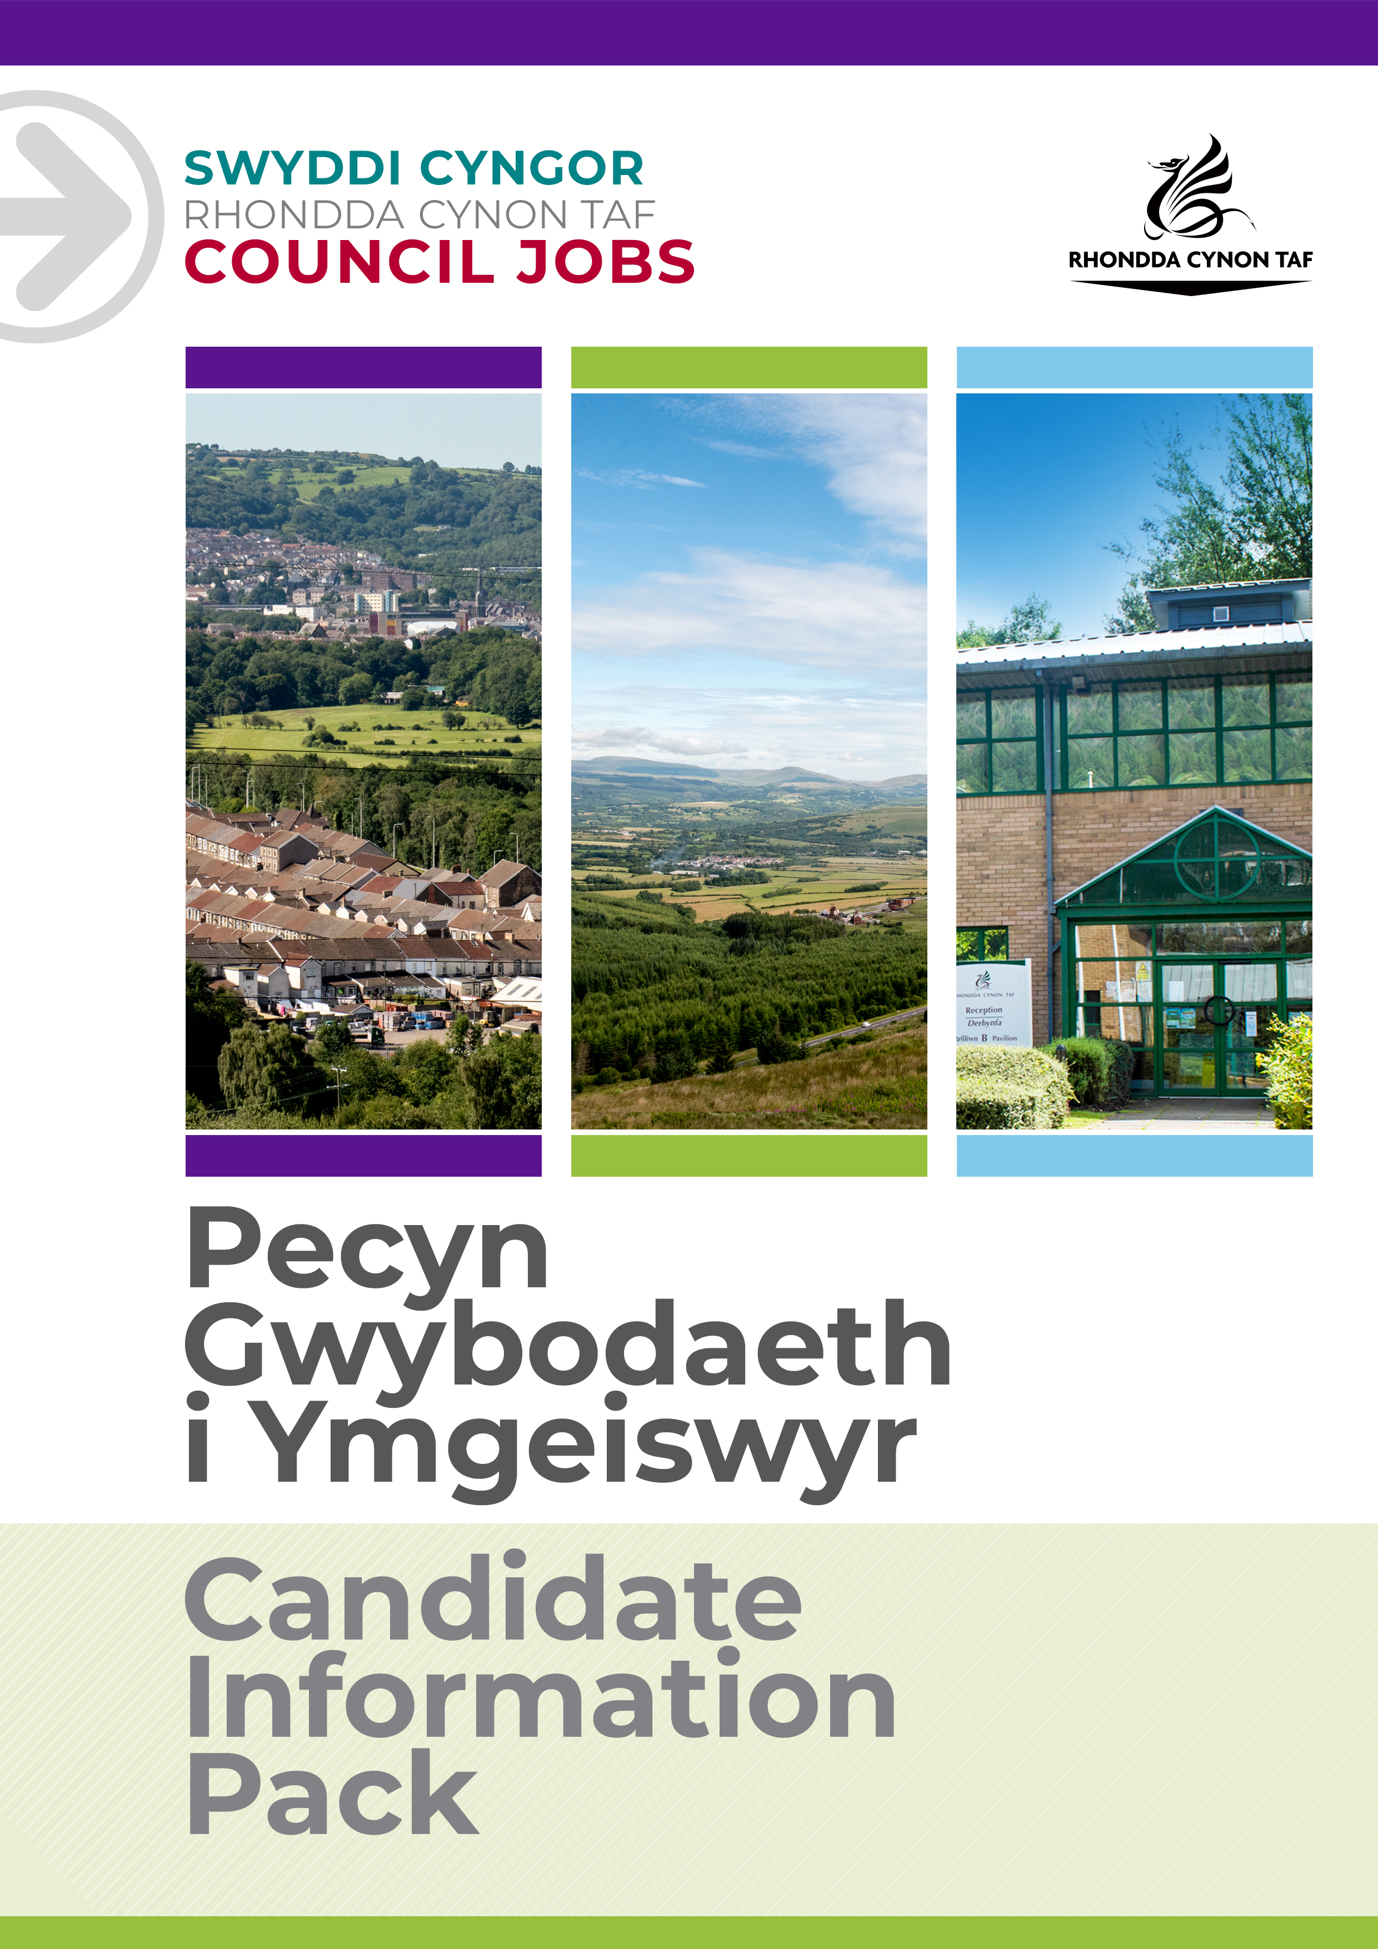
JOB DESCRIPTION

Casual Event Assistant – To positively raise the profile of the Council by assisting in the organisation of the special events programme.

To assist in the practical delivery of events.

Post Reference Number:11806
Date of Job Description: September 2022
Version: 1

 | Grade | GR1
 | Location | Office / Various Locations

 | Group | Prosperity, Development & Frontline Services
 | Division | Prosperity & Development
 | Department/Section | Corp. Publications, Events, Marketing
 | Team/Sub Section | Events

 | Responsible to | Senior Events Co-ordinator
 | Posts reporting to this post | None

 | DBS Required | N/A

Why work for Rhondda Cynon Taf Council?

Rhondda Cynon Taf Council is one of the largest Local Authorities in Wales and our vision is “for Rhondda Cynon Taf to be the best place in Wales to live, work and play, where people and businesses are independent, healthy and prosperous”.
If you work for us, everything you do will be about making a positive difference to our community and the public sector.
Our excellent induction, training and development programmes will help you grow in your role. You will be challenged and supported, with the opportunity to learn new and transferable skills whilst playing your part in helping others.
Please see our career pages to find out more about working for us.

Purpose of the post:

Manager to complete
To assist with the delivery and set up of live events such as Aberdare, Festival, Big Welsh bite and Santa’s Toy Mine

What you will deliver:

- Setting up and siting equipment in preparation for events e.g. crowd control barriers, signage marquees etc.
- Taking down equipment and storing it at the end of the event.
- Erecting temporary directional signs and or public information notices.
- Taking down temporary signs at the end of the day
- General Marshalling duties e.g. directing public, providing information.
- Assisting with car parking / traffic control
- Litter picking
- Market research, leaflet distribution, banner erecting
- Any other duties as required

To undertake such other duties and responsibilities commensurate with the grade, as may be reasonably required by the Service Director, or as a mutually agreed development opportunity.
To comply with the Council’s Health and Safety Policies and procedures and undertake any relevant health and safety duties in accordance with local arrangements.
To support the Council to play its part in tackling Climate Change and meeting its Carbon Reduction targets across the services it delivers and also in the goods and services it buys or commissions from other organisations.
All staff have a valuable and vital role in keeping people safe. Any person with concerns regarding the safety of a child or adult at risk, OR the behaviour of a colleague towards a child or adult at risk, has a responsibility to report this immediately. This should be done via the person’s Line Manager, Designated Safeguarding Lead or contact the Cwm Taf Multi Agency Safeguarding Hub.

THE CONTENTS OF THE DOCUMENT WILL BE SUBJECT TO REVIEW FROM TIME TO TIME IN CONSULTATION WITH THE POST HOLDER. JOB DESCRIPTIONS MAY BE AMENDED TO REFLECT AND RECORD SUCH CHANGES.

PERSON SPECIFICATION
This Person Specification sets out the knowledge and/or qualifications, past experience and personal competencies that would be ideal for this particular post.
The Knowledge/Qualifications and Experience sections describe what is required in terms of the technical ability that is needed to do this job successfully.
The Competencies section describes the kinds of non-technical skills, abilities and personal characteristics that the ideal person for this particular role would have. The competencies describe how that person would ideally work with other people and how they would approach their responsibilities.
The Special Conditions and Professional Requirements section describes any other qualities appropriate to the particular circumstances associated with this role.
Knowledge / Education:
 | Essential | Desirable
 | Welsh Language Level 1 – All employees will be required to undertake a basic Welsh Language Induction to reach this level. | Welsh Language Level 2 to Level 5. For details on the levels please refer to The Welsh Language Skills Guidelines, which can be found in the Welsh Services section of the RCT Council Website.
 |  | Knowledge of Council run events.
 |  | Knowledge of local area.

Experience:
 | Essential | Desirable
Experience of working within an events or marketing environment.
Experience of communicating confidently with the general public.

Welsh language skills:
 | Essential | Desirable
 | Welsh Language Level 1 ☒  All employees will be required to undertake a basic Welsh Language induction to reach this level  Welsh Language Level 2 ☐  Welsh Language Level 3 ☐  Welsh Language Level 3-5 ☐  Welsh Language Level 4 ☐  Welsh Language Level 5 ☐ | Welsh Language Level 2 ☐  Welsh Language Level 3 ☐  Welsh Language Level 3-5 ☒  Welsh Language Level 4 ☐  Welsh Language Level 5 ☐
 | For details about the levels please refer to ‘The Welsh Language Skills Guidance’ online: www.rctcbc.gov.uk/WelshSkills

What skills you will use in the workplace:

 | Competency Framework | Frontline and Customer Care Competency Framework
 | Competency Areas | Competency behaviours and values
 | Communicating Effectively | Shares information with others; gives others the full picture.
 | Demonstrating Professionalism | Always demonstrates that they take pride in representing the Council.  Is responsible, trustworthy and reliable and takes personal accountability for work.
 | Working with Others | Is tactful, polite and respectful.
 | Meeting Customers’ Needs | Considers the needs of different groups, e.g. Children, Senior Citizens, Disabled People.
 | Achieving Results | Is always punctual and ready to start work on time.

Special Conditions and Professional Requirements

Ability to travel independently throughout Rhondda Cynon Taf.

