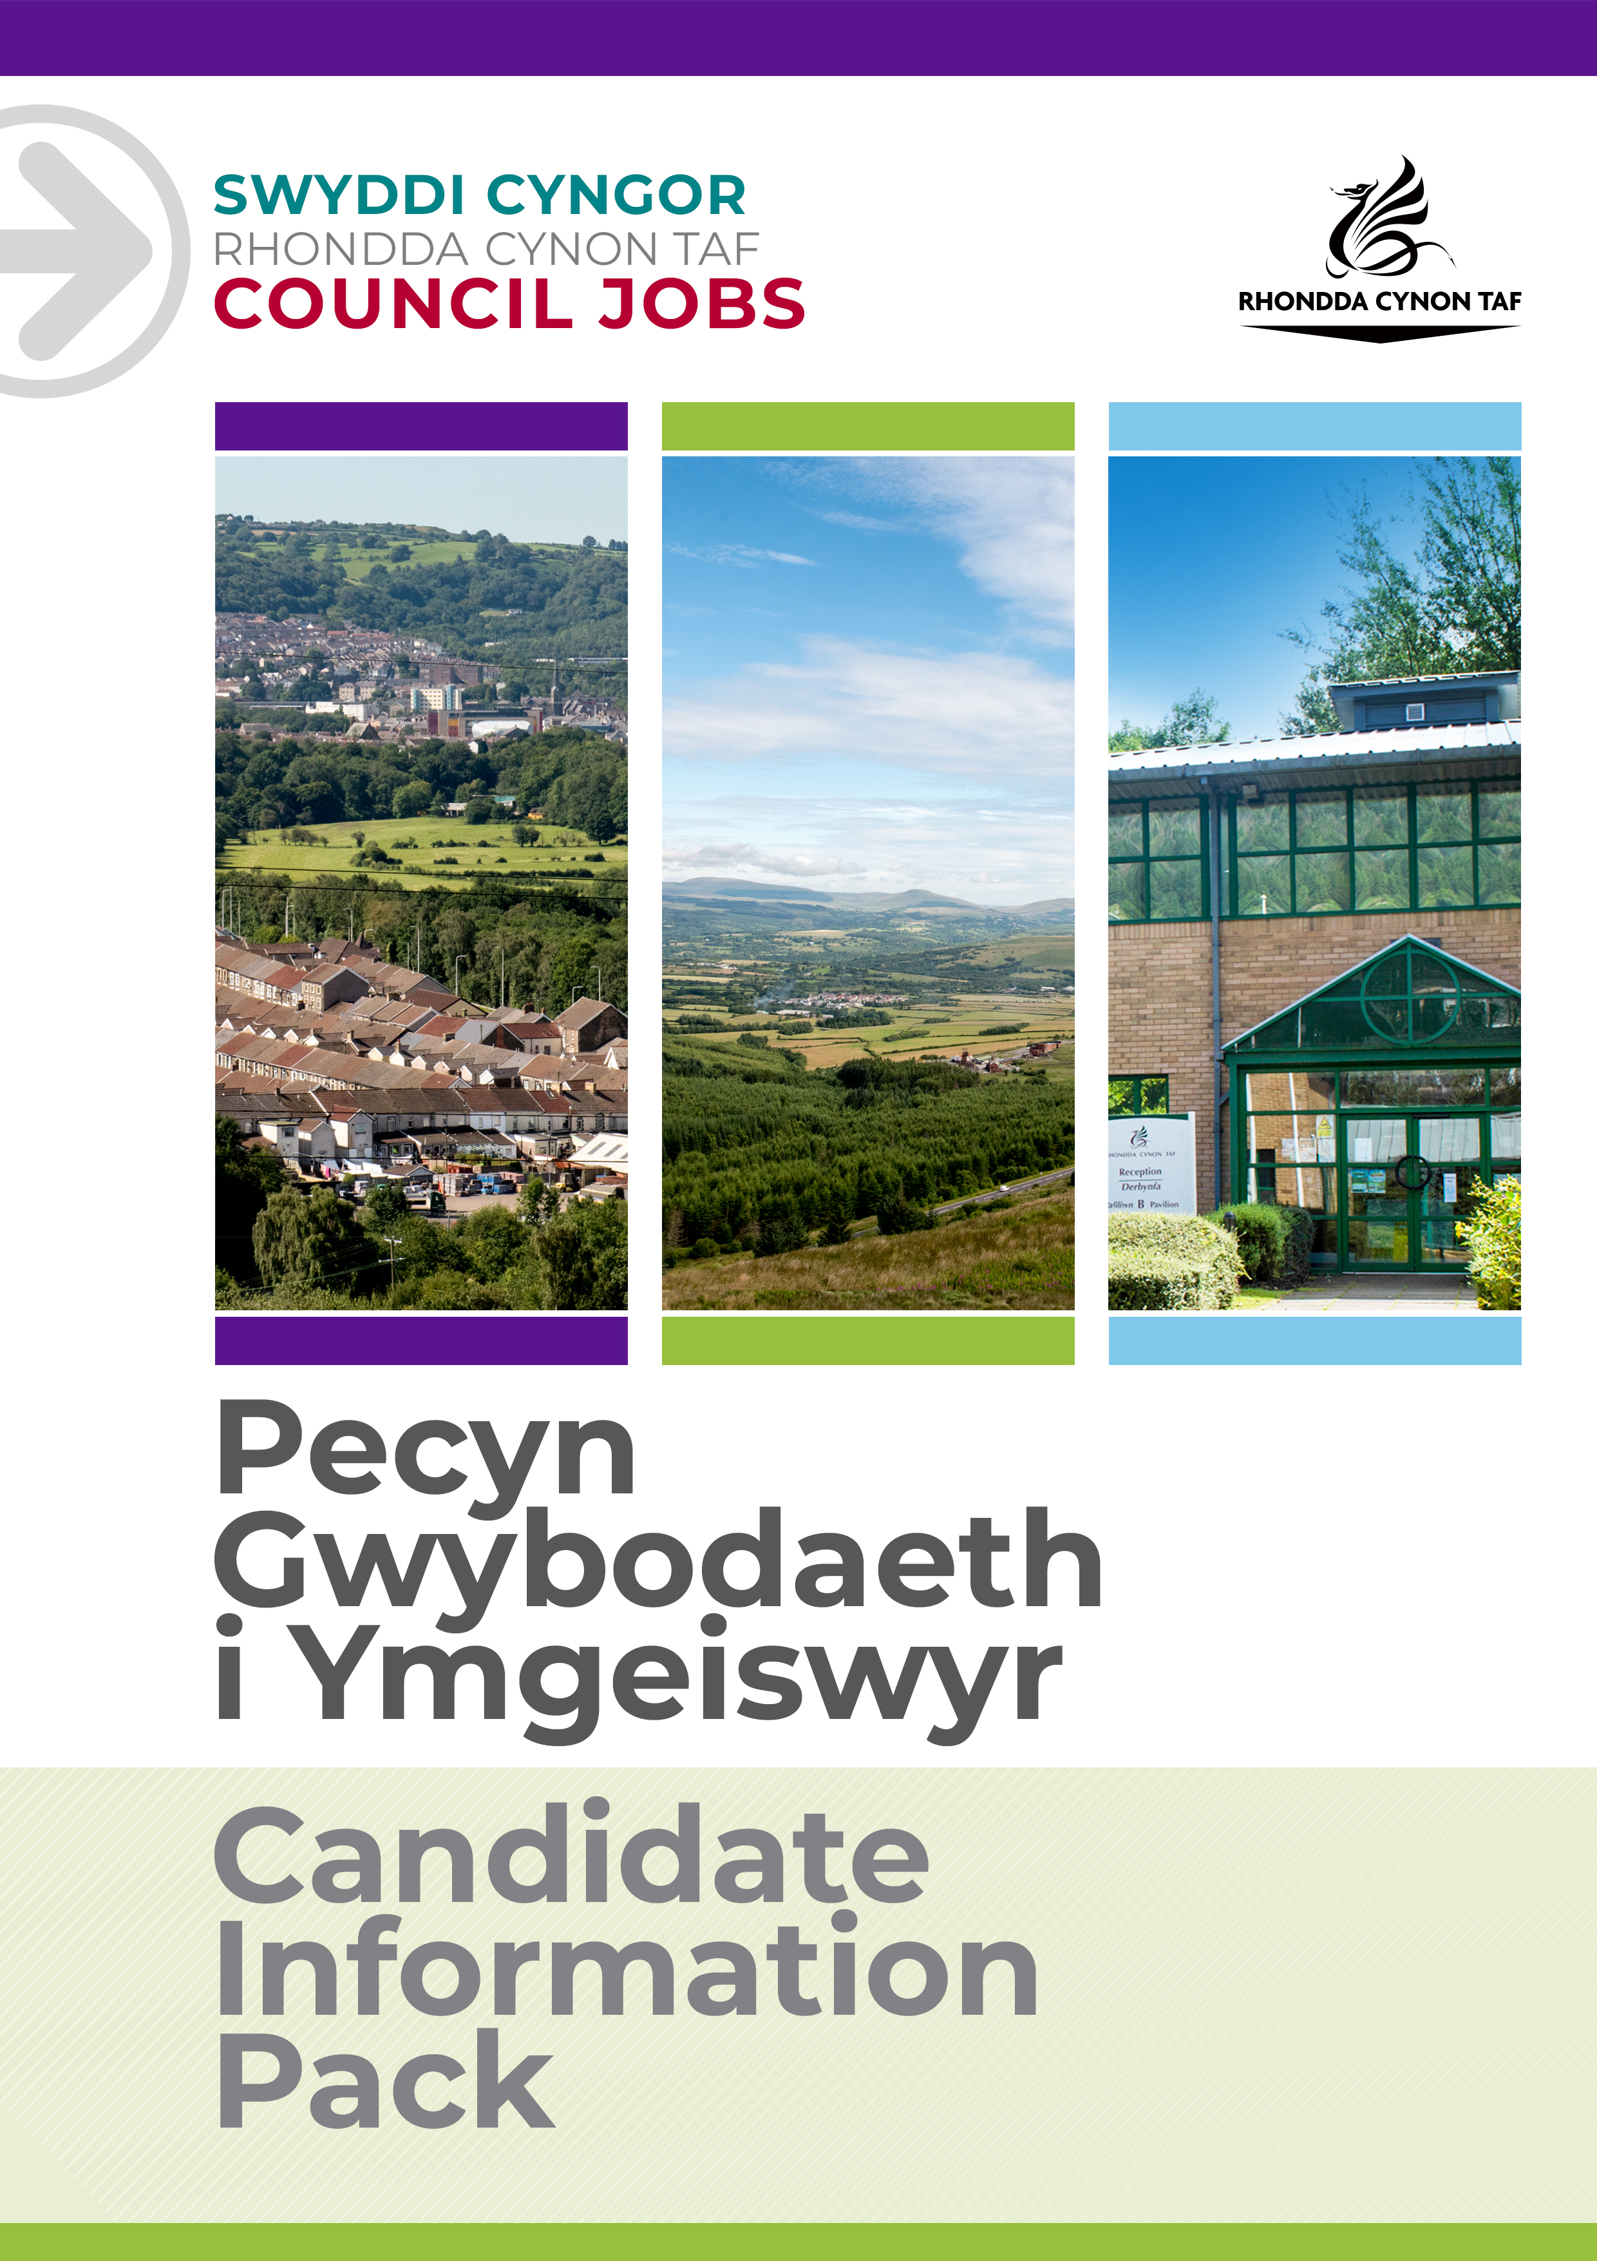
JOB DESCRIPTION

EDUCATIONAL PSYCHOLOGIST

Post Reference Number: POST000528
Date of Job Description: April 2022
Version:1

 | Grade | SOULBURY SCALE A – POINTS 2-7 (+ POTENTIAL OF UP TO 3 SPAS)
 | Location | TY TREVITHICK, ABERCYNON

 | Group | EDUCATION + INCLUSION SERVICES
 | Division | INCLUSION SERVICES
 | Department/Section | ACCESS + INCLUSION
 | Team/Sub Section | EDUCATIONAL PSYCHOLOGY

 | Responsible to | HEAD OF EDUCATIONAL PSYCHOLOGY
 | Posts reporting to this post | NONE

 | DBS Required | ENHANCED

Why work for Rhondda Cynon Taf Council?

Rhondda Cynon Taf Council is one of the largest Local Authorities in Wales and our vision is “for Rhondda Cynon Taf to be the best place in Wales to live, work and play, where people and businesses are independent, healthy and prosperous”.
If you work for us, everything you do will be about making a positive difference to our community and the public sector.
Our excellent induction, training and development programmes will help you grow in your role. You will be challenged and supported, with the opportunity to learn new and transferable skills whilst playing your part in helping others.
Our generous annual leave allowance will provide you with 25 days holidays (pro rata, increasing to 30 upon 5 years of completed service), in addition to 8 public holidays. We have an excellent pension scheme with employer contributions and our financial support benefits will help to give you a sense of security and wellbeing for the future. We care about the wellbeing of our staff and our family friendly and inclusive policies allow for flexibility when needed. We offer support and advice including counselling, health surveillance, nurse and physiotherapy services. There are also a number of staff networks for employees including the Allies Network, a Disability and Carers Network, Perthyn our LGBTQ+ Network and Spotlight, open to Black, Asian and minority ethnic staff.
In addition, you will have access to a wide range of staff benefits including discounted ‘Leisure for Life’ membership, ‘Vectis Card’ for discounts on hundreds of products and services, Cycle to Work scheme and a technology purchase scheme.
Please see our career pages to find out more about working for us.

Purpose of the post:

- To assist in the delivery of Educational Psychology Services to children and their families. To provide psychological support and advice to pre-school and school settings.
- To use psychology to assist Rhondda Cynon Tad and Merthyr Tydfil Local Authorities in meeting the needs of children and young people and fulfilling the LA’s statutory obligations.
- To assist in the identification of strengths and difficulties of children and young people who have Additional Learning Needs (ALN) within the County Boroughs. To advise appropriate provision to meet their ALN.
- To take a lead role in assisting schools, teachers, parents and other partner agencies with regards to ALN reform.
- To deliver interventions, including therapeutic work and training as needed.
- To assist in research that enables the progressions of positive, evidenced based practice at all levels within the LA.

Professional Supervision and CPD will be provided by the EPS

What you will deliver:

These duties might involve work at an individual, group and organisational level.

Individual Work

- The assessment of pupils (aged 0 – 25 years) who present with significant additional needs.
- Consultation with a range of professionals and others on the development of suitable interventions to bring about positive change.
- To promote positive outcomes through consultation using person centred approaches and provide a psychological input to enhance success.
- Support families and schools to promote positive outcomes for children.
- Supporting schools to develop person centred approaches, programmed and packages to support inclusion and engagement.
- Facilitating the involvement of children and young people in the evaluation and monitoring of their progress.
- Providing support for children and their families with significant emotional, social, and behavioural needs.
- Support pupils who are educated in specialist provisions through dedicated time for assessment, support, and training.
- Give detailed advice on the needs of pupils during transitions and advocated for them as needed.
- Ensuring that the voice and views of the child and young person are heard.
- Sharing information with other professionals on evidence-based interventions.
- Providing training and support where required.

Group Work

- Consultation with key staff on issues that might impact on the successful inclusion and engagement of children and young people.
- Running small group interventions (e.g parenting, managing anxiety, social skills training, mindfulness etc)
- Organisation and delivery of group consultation sessions for school staff/ALNCos

Organisational Work

- Consultation with managers, Headteachers and ALNCos on whole school issues relating to additional learning needs.
- Involvement in ELSA training programmes and supervision.
- Contributing to multi-agency planning and review meetings, and the delivery of joint interventions.
- Working with other agencies to support child protection practices.
- Involvement in action-based research when requested.
- Contributing to LA initiatives and strategic projects when requested.
To undertake such other duties and responsibilities commensurate with the grade, as may be reasonably required by the Service Director, or as a mutually agreed development opportunity.
To comply with the Council’s Health and Safety Policies and procedures and undertake any relevant health and safety duties in accordance with local arrangements.
To support the Council to play its part in tackling Climate Change and meeting its Carbon Reduction targets across the services it delivers and also in the goods and services it buys or commissions from other organisations.
All staff have a valuable and vital role in keeping people safe. Any person with concerns regarding the safety of a child or adult at risk, OR the behaviour of a colleague towards a child or adult at risk, has a responsibility to report this immediately. This should be done via the person’s Line Manager, Designated Safeguarding Lead or contact the Cwm Taf Multi Agency Safeguarding Hub.

THE CONTENTS OF THE DOCUMENT WILL BE SUBJECT TO REVIEW FROM TIME TO TIME IN CONSULTATION WITH THE POST HOLDER. JOB DESCRIPTIONS MAY BE AMENDED TO REFLECT AND RECORD SUCH CHANGES.

PERSON SPECIFICATION
This Person Specification sets out the knowledge and/or qualifications, past experience and personal competencies that would be ideal for this particular post.
The Knowledge/Qualifications and Experience sections describe what is required in terms of the technical ability that is needed to do this job successfully.
The Competencies section describes the kinds of non-technical skills, abilities and personal characteristics that the ideal person for this particular role would have. The competencies describe how that person would ideally work with other people and how they would approach their responsibilities.
The Special Conditions and Professional Requirements section describes any other qualities appropriate to the particular circumstances associated with this role.
Knowledge / Education:
 | Essential | Desirable
 | Masters or Doctoral qualification as an Educational Psychologist

Experience:
 | Essential | Desirable
 | Experience of Working with children and young people and their families/carers | Experience of a range of educational provisions
 | Experience of using a variety of psychological interventions | Experience of providing group interventions
 | Experience of using person centred approaches | Experience of providing individual support
 | Experience of developing and using evaluation tools and research to inform practice | Experience of developing and delivering training
 |  | Experience of multi-agency liaison
 |  | A knowledge of current and proposed government aims and initiatives regarding additional learning needs
 |  | A knowledge of current thinking and research within education

Welsh language skills:
 | Essential | Desirable
 | Welsh Language Level 1 ☒  All employees will be required to undertake a basic Welsh Language induction to reach this level  Welsh Language Level 2 ☐  Welsh Language Level 3 ☐  Welsh Language Level 3-5 ☐  Welsh Language Level 4 ☐  Welsh Language Level 5 ☐ | Welsh Language Level 2 ☒  Welsh Language Level 3 ☒  Welsh Language Level 3-5 ☒  Welsh Language Level 4 ☒  Welsh Language Level 5 ☒
 | For details about the levels please refer to ‘The Welsh Language Skills Guidance’ online: www.rctcbc.gov.uk/WelshSkills

What skills you will use in the workplace:

 | Competency Framework | Tech. Specialist and Prof. Competency Framework
 | Competency Areas | Competency behaviours and values
 | Working in Partnership and Teams | Builds lasting, positive, and supportive relationships with a wide variety of people.  Knows when it will be most effective to work as a team and when to work alone and works well in both.  Is proactive and positive about giving support, advice, guidance and sharing best practice with colleagues.
 | Communicating Effectively | Has a pleasant and friendly communication style.
 | Professional Expertise and Development | Is positive about continuous professional development (CPD) and seeks opportunities to improve own knowledge.  Demonstrates excellent practice and an extensive knowledge base in their own professional area.
 | Achieving Results | Is flexible to ongoing demands and knows when to compromise.  Takes pride in delivering high quality work for the benefit of Service Users. Meets or exceeds targets.  Makes decisions based on a wide range of information.  Is proactive and flexible to changing demands and knows when to compromise.
 | Focusing on Service Users | Treats customers in a non-judgemental, polite, and respectful way.
 | Creating and responding to change | Finds ways to use new learning.
 | Being Accountable | Takes full responsibility for delivery of tasks.

Special Conditions and Professional Requirements

The ability to travel independently around the County Borough Council areas.

